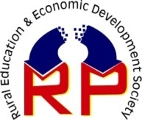

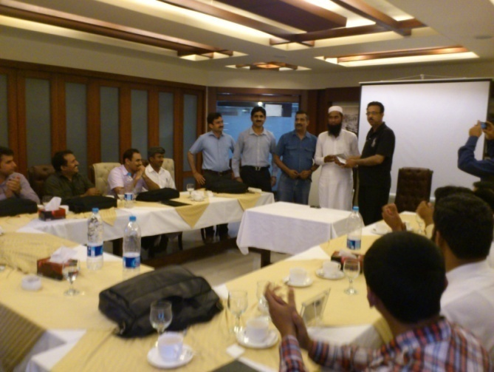

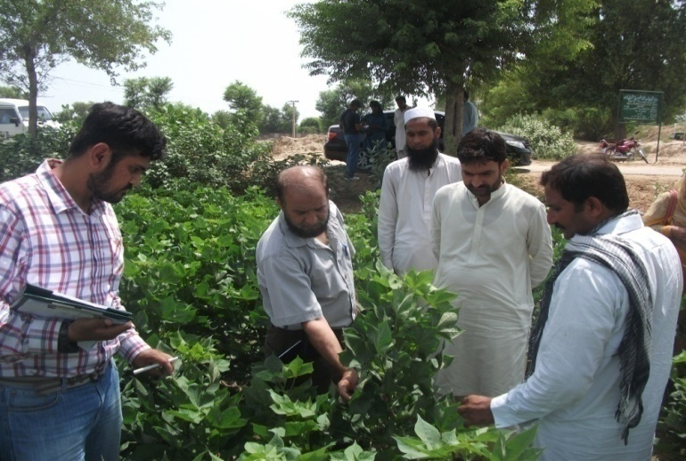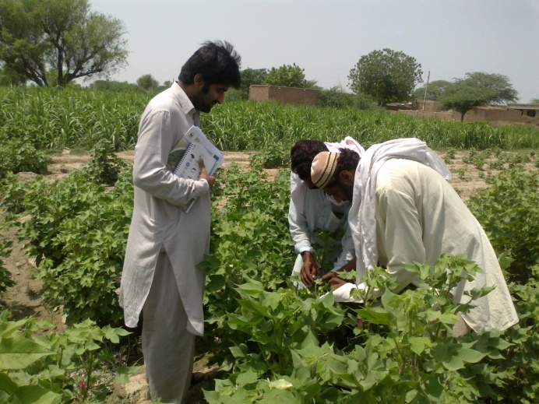

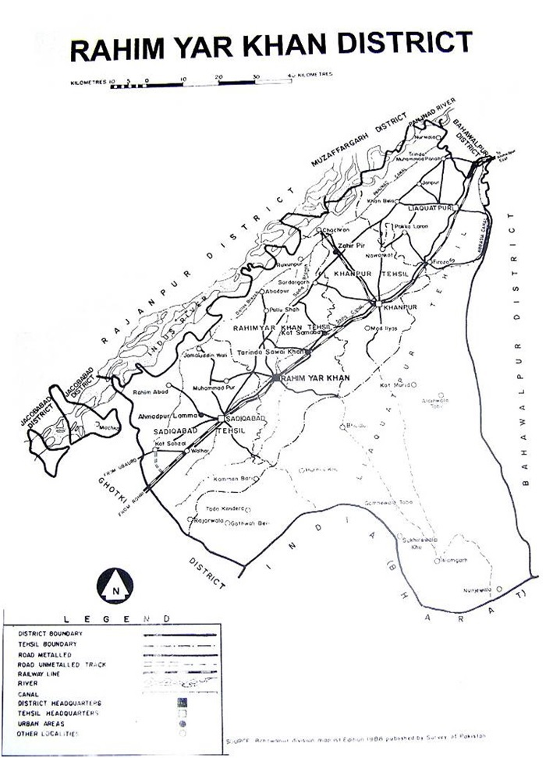 **ACKNOWLEDGMENT**

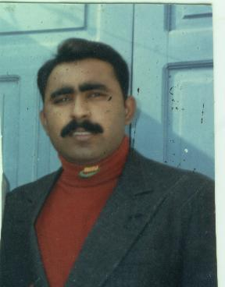

The success of this project is the result of a genuine support and cooperation of different stakeholders at various levels. Since the introduction of the project in March, 2013 REED-PK has received assistance and advice from various people/ organizations. REED-PK would like to express their sincere appreciations to WWF-RYK in general for their technical and financial support throughout the project lifetime.

Their financial support has enabled REED-Pk to reach the targeted grassroots farmer community easily and deliver Better Cotton Management Practices under the ***project "Pakistan Sustainable Cotton Initiatives (PSCI)"***, with the objective of globally raising the sustainability standard of conventional cotton and making it available in large volumes to mainstream retailers at the same price as conventional cotton i.e. cotton production better for the people who produce it, better for the environment it grows in and better for the sector’s future.

REED-Pk under the guidelines of WWF- RYK and his past experiences implemented successful techniques of Better Management Practices for improved farming practices, improved agricultural extension techniques, Decent Work criteria of Better Cotton Initiative under its cotton work through participatory approaches. The provision of reading and learning materials as well as various technical trainings and telephonic coaching and discussions had an impact on the promotion of better cotton in a simple and understandable way.

REED-RYK also acknowledge the government officers at various levels (District, UC, Village) for assisting the project by organizing/ permitting public meetings so enabling facilitators to disseminate better cotton message to the farmers. The cooperation and facilitation by the project officer Mr. Muhammad Nasir and team were a magnificent. Appreciations also go for the cooperation given by Human Development Foundation (HDF-RYK), DO-Agriculture, EDO-Education, EDO Health and target areas health and education institutions at all levels by accepting the facilitators to promote decent work.

Exceptional recognition to Dr. Muhammad Shafiq, Country Representative BCI and Mr. Muhammad Abu Bakar District Project Coordinator WWF-RYK who worked with us was providing technical and moral support to the Focal Person, Documentation Officer, Expert Field Facilitator, Field Facilitators and REED-RYK office in general. They had contributed a lot towards the success of the project.

We also acknowledge the DO/EFF/FF who devoted their whole time to provide technical education to the community. Our admiration particularly goes with Mr. Muhammad Riaz and Muhammad Ghulam Ahmed for their great leadership and management.

We can’t thank everyone individually but may our acknowledgement reach all those who in one way or another have assisted REED-RYK to accomplish the project successfully.

**Shahid Saleem**

Executive Director

REED-Pakistan

|  |  |  |
| --- | --- | --- |
| **Sr.# Sr.#** | **Description** | **Page No.** |
| **1** | **Summary of development by REED-Pk** | **5** |
| **2** | **Goals** | **5-6** |
| **3** | **Objectives** | **6** |
| **4** | **Implementation Methodology** | **6** |
| **5** | **Details of PUs Information** | **6** |
| **6** | **Human Resources Available** | **6-7** |
| **7** | **Description of main activities** | **7-33** |
| 7.1 | Training of Field Activist/Volunteers | 7-8 |
| 7.2 | Team selection for 2013 | 9 |
| 7.3 | BCFTF Project Staff Refresher Workshop | 9-10 |
| 7.4 | Verification And Re-Verification Of Follow Up Area | 11 |
| 7.5 | Soil Sampling and Analysis | 11 |
| 7.6 | Verification and Re-Verification of Farmer Lists | 11 |
| 7.7 | Participatory Rapid Appraisal | 11-12 |
| 7.8 | Reactivation of the Fermenter | 12-13 |
| 7.9 | Feed Back Meeting of Field Staff | 13-14 |
| 7.10 | Dissemination of Agri. Messages | 14 |
| 7.11 | Farm Advisory Services | 14-15 |
| 7.12 | LG Gatherings/Trainings | 15 |
| 7.13 | Some of the results/impacts of the LG trainings of the BCI-Farmers | 16-17 |
| 7.14 | Wall Chalking | 18 |
| 7.15 | Peer Review | 18-19 |
| 7.16 | President and Secretary/ Scribe Training | 19 |
| 7.17 | Field Staff Self Assessment Training | 19-20 |
| 7.18 | Decent Work Activities | 20-26 |
| 7.19 | Spray man Training | 26-27 |
| 7.20 | Worker Families Training | 27-28 |
| 7.21 | Rickshaw Announcement | 28-29 |
| 7.22 | Cotton Picker’s Training | 29-31 |
| 7.23 | Credibility Checks | 31 |
| 7.24 | 2nd Credibility by BCI | 31 |
| 7.25 | 2nd party by IP | 31-32 |
| 7.26 | 3rd Party by BCI | 32-33 |
| 7.27 | Wheat Collection (A step toward Sustainability) | 33 |
| **8** | **Data Analysis** | **33-37** |
| **9** | **Conclusion** | **38** |
| **10** | **Annexure** | **38-47** |

**1-Summary of development by REED-Pk:**

Pakistan is blessed with vast land, vast natural resource base, covering various ecological and climatic zones; with one of largest and best irrigation systems in the world. Cotton is the most important cash crop declared as ‘White Gold’ all over the world. Livelihood of millions of people, farmers and cotton picker females is linked with this cash crop in Pakistan. Fiber of cotton is proved scientifically to be the most suitable material for human clothing and preferred natural fiber for fashion and design fabrics all over the world. To meet the increasing demand of this crop, quality and quantity of the crop is manipulated by improving cotton.

Pakistan comprising about 80% of the population continuous to be poor and under developed. More than 80% of rural masses depend directly or indirectly upon agriculture for their livelihood. A large proportion 56% of Pakistan population has income below poverty line and the majority of this group (70%) lives in rural areas. WWF - P is working since 2005 for the development and promotion of site-specific Better Management Practices under the project "Pakistan Sustainable Cotton Initiatives (PSCI)", with the objective of globally raising the sustainability standard of conventional cotton and making it available in large volumes to mainstream retailers at the same price as conventional cotton. The BCI exists to make global cotton production better for the people who produce it, better for the environment it grows in and better for the sector’s future. Keeping in view the importance of agriculture and being the Pioneer Country producing Better Cotton, REED-Pk started activities for widespread promotion and dissemination of Better Management Practices (BMP) as per Better Cotton Initiative (BCI) production principles and criteria through participatory approaches with the collaboration of WWF-Pakistan. Agricultural Better Management Practices (BMPs) are practical, cost-effective actions that agricultural businesses can use to reduce pesticides, fertilizers, animal waste and other pollutants entering our water resources.

The achievements of the Second year 2013 are extraordinary and can be assessed by the fact that over the time, REED-Pk under the guidelines of WWF-Pak-RYK office and his past experiences has implemented successful techniques of Better Management Practices for improved farming practices, improved agricultural extension techniques, Decent Work criteria of Better Cotton Initiative under its cotton work through participatory approaches.

For widespread dissemination of BMPs through participatory approaches such as OVOF, outreach advisory services, establishment of Fermenter, BMP Demo plots, decent work promotion and Farmer gatherings. Throughout the reporting period, several capacity building workshops were organized for Farmer Organizations or Learning Groups to strengthen their capacities to support Producer Units (PU) for Better cotton production. Moreover, capacity building workshops like BMP activist training, Peer Review, Rickshaw announcement, Spray Man’s Training, Worker Families Training, Cotton Picker’s Training were successfully conducted.

During 2013, the project plan was to engage 3899 farmers, organizing them in 99 LGs having 24557 Hectare of Cotton crop in, Tehsil Khan Pur and Liaqatpur District Rahim Yar Khan.

**2-Goals:**

* Implementation of Better Cotton System at farm Level.
* Implementation of BMPs (Better Management Practices) at farm level
* Widespread BMP dissemination at farm level
* Promotion of decent work at farm level

**3-Objectives:**

* To produce better cotton in accordance with the BCI production principles.
* To aware famers about the nature conservation.
* To enhance the capacity of farmers through better management practices.
* To ensure implementation of decent work principles and criteria namely; Freedom of Association and Collective Bargaining, Healthy and Safety, Child labour, Employment Conditions, Non Discrimination, Forced Labour, and Basic Treatment & Disciplinary Action.

**4-Implementation Methodology:**

The OVOF approach is based upon:

* Participatory Discovery Learning Process (PDLP);
* Outreach and Technical Backstopping (OTB);
* Quality Assurance and Monitoring Mechanism (QAMM);
* Feedback Mechanism (FM);
* Continuous skill enhancement and capacity building of Expert Facilitators, Field Facilitators and farming communities;
* Farmer Self Assessment Mechanism (SAM)
* Creditability checks
* Wide Spread Dissemination activities
* Outreach advisory

**5-Details of PUs Information:**

|  |  |
| --- | --- |
| **PU-RYK-RPK 01** | **PU-RYK-RPK 02** |
| Total farmers =3866  SHE =816  FSH =3050  Total cotton cultivated area =21182 Hectare  Total LGs = 99s | Total LFEs =33  Total cotton cultivated area =3374.5 hectare  Expected Yield of BC = 7115544 Kg |

**6-Human Resources Available:**

|  |  |  |  |  |  |
| --- | --- | --- | --- | --- | --- |
| **Sr.#** | Designation | **Qualification** | **No. of Posts** | **Male** | **Female** |
| 1 | Focal Person | M.Sc (Hons) Agri. | 1 | 1 | 0 |
| 2 | Agri. Officer/DO | M.Sc Hons (Agri.) | 1 | 1 | 0 |
| 3 | EFF | Diploma in agriculture/Field Expert and FA | 3 | 3 | 0 |
| 4 | DEO | BA | 1 | 1 | 0 |
| 5 | FF | Passed volunteers training | 19 | 17 | 2 |
| **TOTAL** | | | **25 23** | | **2** |

**7-Description of Main Activities:**

***7.1-Training of Field Facilitators/Activists***

HDF and REED-Pk field team as Field Facilitators, Expert Field Facilitators, District Agriculture Officer, LG presidents and secretaries shared about the FF training with the volunteers in their respective areas. In response of this many volunteers contacted with the Field team and the submitted their CVs. REED-Pk Executive Director and DO conducted two orientations meeting with the volunteers in UC 45/P and Bagh-o-Bahar Tehsil Khanpur District Rahim Yar Khan in which almost 72 volunteers participated. REED-Pk Executive Director briefly introduced the BCI-SAP project and the role of the Field Facilitators. After the orientation sessions interviews conducted in HDF office and in the field and finally 38 volunteers selected for the first training session conducted in Tehsil Khan Pur.

**Objectives:**

* To enhance the capacities of the volunteers and develop their skills regarding sight specific Better Management Practices (BMPs) and make sight specific right crop management decisions.
* To train new staff/volunteers for the better implementation of BCI PPs, MPCS for next year

**Methodology:**

Process of training was participatory. The participants were involved through different techniques like

* Pre-Test
* brain-storming
* group work
* lectures followed by question and answer sessions
* Reading materials and multi-media presentations were distributed
* Post-Test

**Facilitators:**

|  |  |  |  |
| --- | --- | --- | --- |
| **Sr.#** | **Name** | **Designation** | **Organization** |
| 1 | Shahid Saleem | Executive Director | REED-Pk |
| 2 | Nadir Ali | District Agriculture Officer | REED-Pk |
| 3 | M. Hammad | Program Coordinator IPM | HDF |
| 4 | Ghulam Ahmed | Expert Field Facilitator | REED-Pk |

**Results of Pre and Post Test:**

**Facilitator’s observation/remarks:**

The participants enthusiastically actively participated in all sessions which maintained their interest and was a moral support to Facilitator. The attendance of participants was highly appreciated. The participants really appreciated the workshop saying for the first time in the history of Rahim Yar Khan such a program happened and it is really a rare one for the betterment of the farmers or agriculture community!

**Outcomes;**

* The capacity of 31 volunteers (Field Facilitators) regarding Better Cotton System, Production Principles, Better Management Practices, modern approaches etc enhanced.
* The survey of almost 20000 acres collected while rest is in process.
* The confidence of the Facilitators enhanced for future trainings and field activity

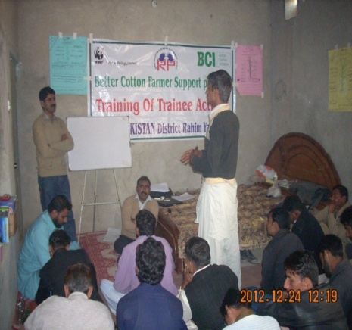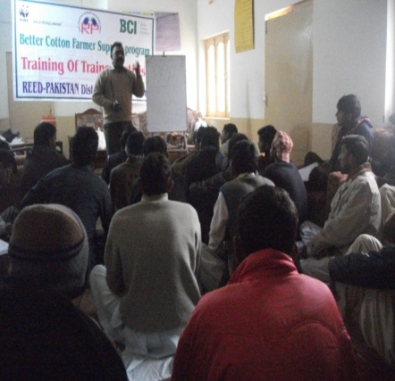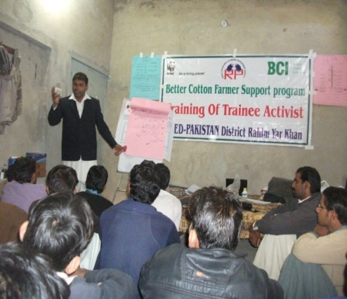

Mr. M. Hammad Program Coordinator HDF during his session

Mr. M. Abubakar District Coordinator WWF-Pk during visiting the training

Mr. Shahid Saleem Executive Director REED during his session

***7.2-Team selection for 2013***

After the MOU with the WWF-P REED-Pk identified following staff as per organizational policy and procedure.

|  |  |  |  |  |  |
| --- | --- | --- | --- | --- | --- |
| **Sr.#** | Designation | **Qualification** | **No. of Posts** | **Male** | **Female** |
| 1 | Focal Person | M.Sc (Hons) Agri. | 1 | 1 | 0 |
| 2 | Agri. Officer/DO | M.Sc Hons (Agri.) | 1 | 1 | 0 |
| 3 | EFF | Diploma in agriculture/Field Expert and FA | 3 | 3 | 0 |
| 4 | DEO | BA | 1 | 1 | 0 |
| 5 | FF | Passed volunteers training | 19 | 17 | 2 |
| **TOTAL** | | | **25** | **23** | **2** |

***7.3-BCFTF Project Staff Refresher Workshop:***

**Introduction:**

For widespread dissemination of BMPs through participatory approaches such as OVOF, outreach advisory services, establishment of Fermenters, BMP Demo plots and Farmer gatherings. REED-Pk organized six days training for the Staff to be part of Sustainable Agriculture Project in 2013 as Field Facilitators.

**Objective:**

* To enhance the capacities of the project staff and develop their skills regarding sight specific Better Management Practices (BMPs) and make sight specific right crop management decisions.
* 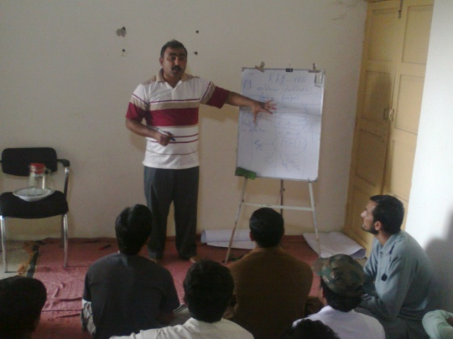To refresh the knowledge of the project staff for the better implementation of BCI, BCS, DW, PPs, MPCS for year 2013.

**Activities:**

* Project Orientation meeting with the Staff
* Curriculum Development
* Commitment with the Facilitators
* Selection of the training hall
* Six days training
* Working area distribution to DO, EFF and FF

**Methodology:**

Process of training was participatory. The participants were involved through different techniques like

* Brain-storming
* 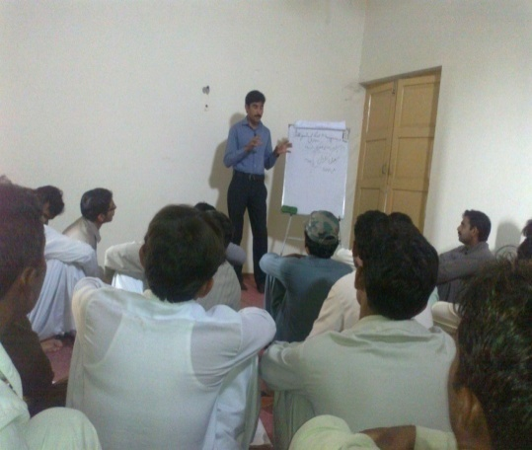group work
* lectures followed by question and answer sessions

**Facilitators:**

The facilitators had profound knowledge and years of experience in the field of conducting trainings for Agriculture both, theoretical and practical information provided by the facilitators was extremely relevant to the working conditions of the participants.

|  |  |  |  |
| --- | --- | --- | --- |
| **Sr.#** | **Name** | **Designation** | **Org.** |
| 1 | M. Nasir | Senior Project Officer | WWF-P |
| 2 | Shahid Saleem | Executive Director | REED-Pk |
| 3 | Qazi M. Rizwan | Agriculture Officer | REED-Pk |
| 4 | Ghulam Ahmed | Expert Field Facilitator | REED-Pk |
| 5 | M. Asghar Qazai | Expert Field Facilitator | REED-Pk |

All the facilitators covered agenda in six days i.e. Soil Management, Micro Nutrients, Identification of weeds and management, green manuring, compost, FYM, Importance of Fermenter, Cotton diseases, pesticide management, sucking pests, affect of pesticides on environment, beneficial insects, Chewing pests, PRA and CAP, DW, Facilitation Skills, Field trials and BMPs.

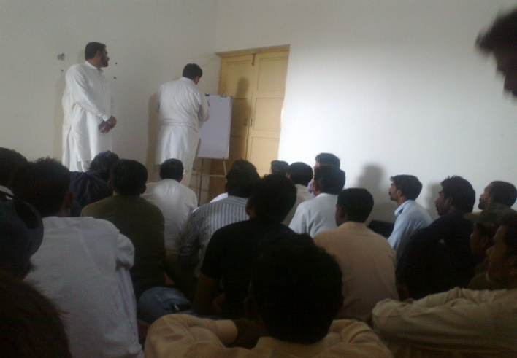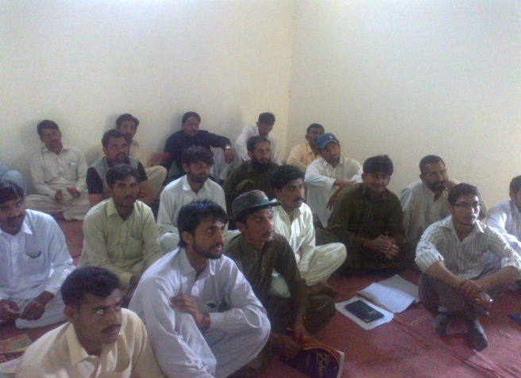

.

**Facilitator’s Observation / Remarks:**

The staff enthusiastically actively participated in all sessions which maintained their interest and was a moral support to Facilitator. The attendance of staff was highly appreciated.

**Outputs:**

* The capacity of 21 Staff (Activist/Field Facilitators/EFF/AO) regarding Better Cotton System, Production Principles, Better Management Practices, modern approaches etc enhanced.
* The confidence of the Facilitators enhanced for future trainings and field activity.

***7.4-Verification And Re-Verification Of Follow Up Area:***

Follow up area under Better Cotton 100 % verified. FF verified 100% LGs, EFF verified 30% LGs, AO/DO verified 15% LGs and FP/PO verified 5% LGs. Some of the farmers have left that area, some were found fake, some farmers have transferred their lands to sons and only few farmers were found dead. The area under cotton cultivation has also been reduced by some farmers due to shortage of water. New LGs have also been added with follow up area. 99LGs finalized for 2013.

***7.5-Soil Sampling and Analysis:***

Optimum fertility management is a key practice in crop development and performance, in foliar disease management, and in managing the profitability of the crop. In many cases, excess nitrogen is applied to the crop and is not utilized, or becomes a pollutant in ground and surface water. With soil sampling, residual nitrogen and other nutrients and trace elements can be managed for specific needs of a crop while saving variable costs, which may contribute to better overall profitability.

Heavy treatment of soil with pesticides can also cause populations of beneficial soil microorganisms to decline. Overuse of chemical fertilizers and pesticides have effects on the soil organisms that are similar to human overuse of antibiotics. Indiscriminate use of chemicals might work for a few years, but after awhile, there aren't enough beneficial soil organisms to hold onto the nutrients. So keeping in view the importance of soil analysis, 130 soil samples representing the target area from 99 LGs were taken and analyzed. Farmers were guided as per soil analysis report about the application fertilizer type and doze.

***7.6-Verification and Re-Verification of Farmer Lists:***

The team consisting of AO/EFF/FF 100% verified follow up area under Better Cotton. FF verified 100% LGs, EFF verified 30% LGs, AO/DO verified 15% LGs and FP/PO verified 5% LGs. Some of the farmers have left that area, some were found fake, some farmers have transferred their lands to sons and only few farmers were found dead. The area under cotton cultivation has also been reduced by some farmers due to shortage of water. New LGs have also been added with follow up area. 99 LGs have been established/organized consisting of 3899 farmers and 24557 Hectare of Cotton crop.

***7.7-Participatory Rapid Appraisal***

**Introduction:**

To begin the project REED staff conducted a Participatory Rapid Appraisal [PRA] that enabled these communities to assess their farming practices, livelihood strategies and ecological situation. It also helped the communities to identify opportunities that are necessary to be explored for improvement in these areas. This will hopefully provide bases for sustainable action necessary to effect changes throughout the project’s duration.

**Objectives of the PRA:**

The PRA brought together all stakeholders especially the beneficiary communities to analyze their agricultural practices and farming situation and identify gaps required for improvement. The PRA identified community priority areas within the project’s mandate for sustainable agriculture practices for the possible action.

**PRA TOOLS USED**

The objectives of the project largely determine the type of tools appropriate to generate the required information. In this regard, the team decided to use the following PRA tools;

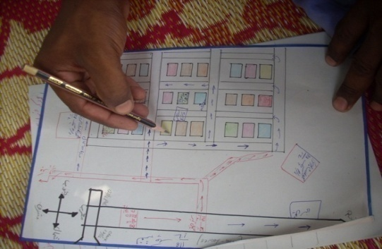

* Social and Resource Map
* Transect walk
* Venn diagram
* Seasonal calendar

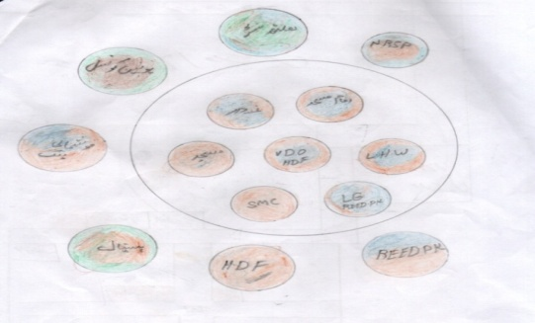The team discussed at length the types of information to be generated from each tool and listed them down. This served as a guide for facilitating group discussions on specific tools, as they will know what type of information they are looking for. Each tool and the information expected to be generated from it follow:

**Seasonal calendar**

Annexure

**Stakeholders Analysis:**

Annexure

**Problem Identification, Ranking and Analysis:**

Annexure

***7.8-Reactivation of the Fermenter:***

Fermenter, a facility for the fermentation, which is a process by which the living cell is able to obtain energy through the breakdown of glucose and other simple sugar molecules without requiring oxygen.

A Fermenter is a 6×4 ft ditch, usually installed at a point of entrance of the water course into the field. REED-Pakistan Field facilitators and EFFs facilitated the farmers for reactivation of the 13 fermenter as a substitute to nitrogenous fertilizers. These resulted in improving the soil texture and its water holding capacity.

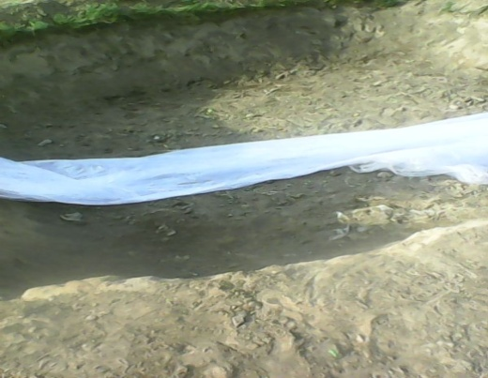



***Farmers’ Feedback:***

BMP farmer using fermenter shared that they were much depressed and in stress for not getting maximum output from the cotton crop as they were applying 2-3 bags of DAP, 4-5 bags of Urea, 2 bags of CAN etc in last three years. They have also observed drying out of the leaves, more height but less bolls and damage or even death of the plant. Crops are at risk during heavy rains or thunder storms; they found their crop lay down in the field and became damaged. He also irrigated 13-16 times.

After becoming the part of the LG they come to know benefits of the organic fertilizer or application of cattle dung through fermenters they shared that ‘’ after the orientation about the Fermenter in the LG meeting they have established 6 x 4 and 12 x 13 ft ditch with inlet and outlet near to the water channel and after lining it with plastic sheet they put the cattle dung in it and fill it with water. After 10 days they irrigated cotton crop through fermenter. Really a dream came true when after eight days they have seen their crop lush green without application of any fertilizer. In the whole season they have only applied on an average 1 and 1/2 bag of Urea/acre and 10 irrigations. Following observations made during using it

* They supply plant nutrients including micronutrients
* They improve soil physical properties like structure, water holding capacity etc.,
* They increase the availability of nutrients
* Plant parasitic nematodes and fungi are controlled to some extent by altering the balance of microorganisms in the soil.
* Crop lush green

***7.9-Feed Back meeting of Field Staff:***

**Feedback** is a process in which information about the past or the present influences the same phenomenon in the present or future. As part of a chain of cause-and-effect that forms a circuit or loop, the event is said to *"feed back"* into itself.

Feedback sessions were conducted in REED-PK Baghobahar Sub Office and Feroza Sub-Office. All FF, EFF and DO were present. The agenda of Feedback were

* Progress of previous activity
* Training issues identified
* Technical Back Stopping
* Fortnight Progress Report
* BMPs Data Collection
* Next month planning and Activities
* Field Issues during Field Visits

***Gaps Identified***

* Knowledge of FF and activist about beneficial insects, sucking pests, disposal of pesticides and containers, registered and non-registered pesticides weak
* Gatherings venue in some places were not as per criteria
* Demo plots not established properly
* Record Keeping is poor in some places
* LG files were not available in some LGs

**Suggestion**

* Special Topics especially on beneficial insects, sucking pests, disposal of pesticides and containers, registered and non-registered pesticides should be delivered by EFFs & FF in their respective area
* EFF ensured Selection of Demo plots at properly
* EFF take responsibility about gathering venue
* EFF facilitate the field staff in record keeping

***CA Follow up***

* Special topics were discussed about beneficial insects and disposal of pesticide container
* EFF ensured the Gathering venue which were proper for the excess of farmers
* 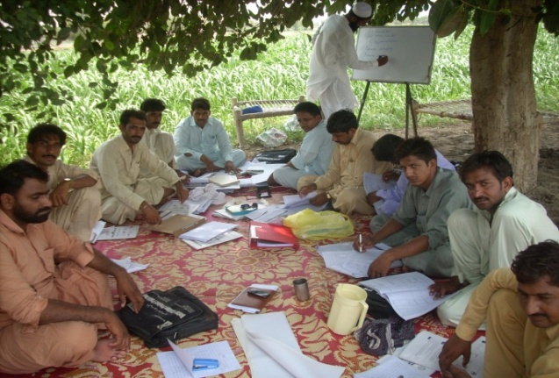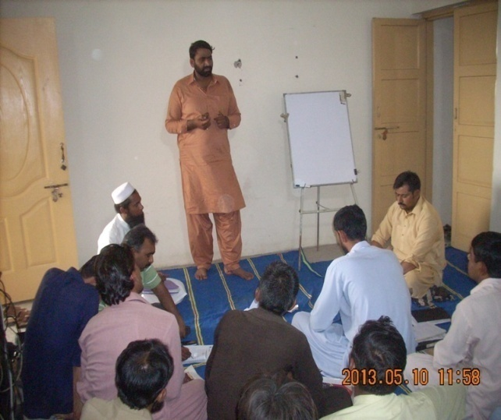EFF facilitate the field staff in record keeping

**7.10-Dissemination of Agri. Messages:**

REED-PK has tried his best to facilitate the farmers through new technologies. In this way agri. pamphlets regarding cotton varieties, sucking pests, kitchen gardening etc were shared among LG members and time to time mobile messages were also shared.

**7.11-Farm Advisory Services:**

The Farm Advisory Services aims at helping farmers to better understand the BMPs and how to apply BCS at farm level properly. Field Facilitators(FF) regularly visited the farmer’s farm along with the farmer and gave them advice as per the crop needs or situation regarding, agronomic and plant protection practices i.e. seed bed preparation, selection of crop varieties, sowing time, sowing methods, seed treatment, spacing, seed rate and fertilizer management, needs of irrigation management, micronutrients, weed control management, application of bio-pesticides and pesticides management as well etc.

The REED-PK staffs also provided quality farm advisory services all over the LGs through its 4 Expert Field Facilitator, 17 Field Facilitator and one Agri. Officer and Focal Person. Each EFF has a team of five/Six Field Facilitator, providing multifarious advisory services through crop demonstrations, field days, farmer meetings, village meetings, Farmer Days, farm visits and group discussions. The advisory services remain continue from land preparation/selection of Cotton Varieties to end of harvesting and then storing. The REED-PK staffs maintain regular contact with farmers and Agricultural Institutions to ensure constant and efficient transfer of latest technology.

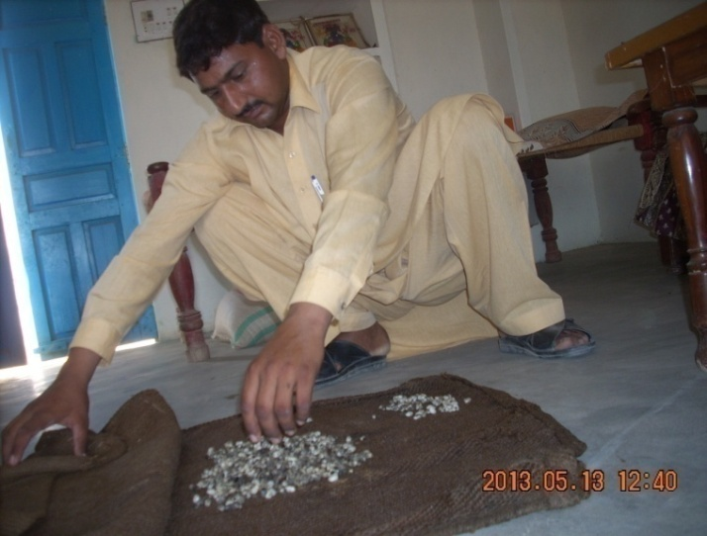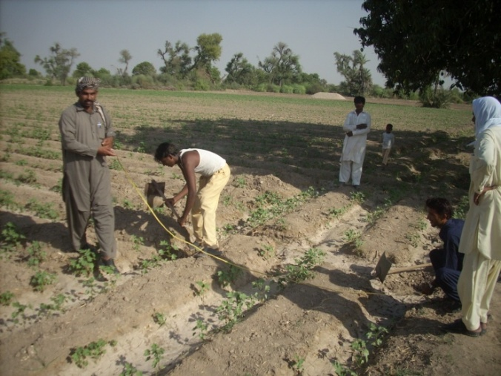

**7.12-LG Gatherings/Trainings:**

Capacity building of the Farmers can bridge the gap between knowledge of the new technologies and changes in the individual farmer's fields which can faster growth of yields and rural income that would occur in the absence of extension. FF, EFF and AO/DO built the capacity of 3899 farmers of 99 LGs having 24557 hectares regarding Land preparation, Production Principles & MPCs, Pest control methods, Special topic (chewing pest) Beneficial insects, Nitrogenous Fertilizer, Better Management Practices e.g. Bajra sowing, Fermenters establishment, Burry the pesticide used containers, Don’t burn the wheat husk, Improved varieties, Biological control, Use water efficiently, Application of Urea Tarwatar, Picking and storage methods.

**7.13-Some of the results/impacts of the LG trainings of the BCI-Farmers**

**Knowledge Enhanced regarding Agronomic Practices**

This included Better Management Practices for land preparation, seed selection, seed sowing, water scouting, techniques used to judge the needs of irrigation for cotton crop by assessing some indicators and symptoms, cotton flowering, maturity of cotton boll and knowledge of participants about cotton weeds and weeds control methods. The farmers in the LG meetings gained on average **72 %** marks as compared to **14 %** at the beginning of the project.

The results indicated **59 %** knowledge enhancement among the LG farmers.

**Knowledge about the application of Fertilizers**

Management of fertilizer was one of the main component during the LG meetings, after the pre-test its has concluded that participants knowledge was limited to only the brand names of fertilizers as Urea, DAP, 23:23 or NP and there no of bags application. However after the training the participant’s knowledge not only improved about their brand name but also about their formulation, proper application and importance of micro-nutrients and their need based used according to the situation and stage of cotton crop as well as using the Synthetic fertilizers in different ways.

The participants gained on average **66 %** marks as compared to **14 %** at the beginning of the training. The results indicated **52 %** knowledge enhancement among the farmers.

**Knowledge about Insects & Pests**

It was really astonishing that the pre-test results showed that LG farmers have only **3.5 %** knowledge about the insects and pests identification, mode of action, life cycle, control etc. of cotton which was the most important factor for implementing BMPs by the BCI-Farmers.

The participants’ knowledge was also assessed about sucking pests, chewing pests, boll worms, beneficial insects and about life cycles of insects and pests.

The participants gained **62 %** marks as compared to **19 %** only at the beginning of the Project. The results indicated 43**%** knowledge enhancement among the participants.

**5.7.4-Knowledge about Pest Control**

Pest control knowledge includes knowing the sustainable approach to managing the pests by combining physical, cultural, biological and Synthetic tools in a way that minimizes economic health and environmental risks. It is now apparent that inappropriate pesticide use is actually exacerbating the pest problems and threatening to the soil air and water environment.

Several key non-Synthetic options that may help reduce the amount of pesticides used were to be discovered by participants through setting up different trials and repetitive applying of the findings. (as destroying of alternate host of pests, light traps, promoting naturally presence of beneficial insects, kore-tuma and akk spray, neem spray etc). The participants gained on average **68 %** marks as compared to **23%** at the beginning of the project activities. The results indicated **45%** knowledge enhancement among the participants.

**7.14- Wall Chalking:**

In the communication field, dissemination means passing a message to the public without direct feedback from the audience. It involves a sender and a receiver whereby information is sent out and received, but no reply is given.

Agricultural publications are considered effective tool to disseminate agricultural information among the farming community.

In this regard Wall chalking with displaying a BMP for cotton is a good source of Learning both for villagers and out of villagers.

6 wall chalking done in this year.

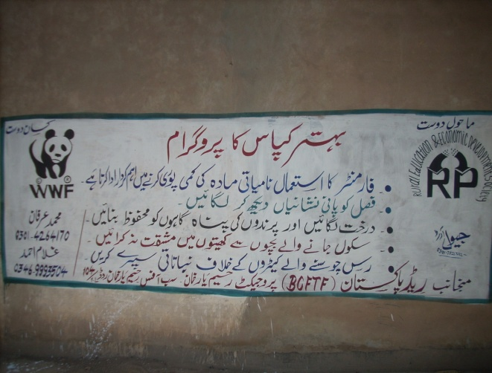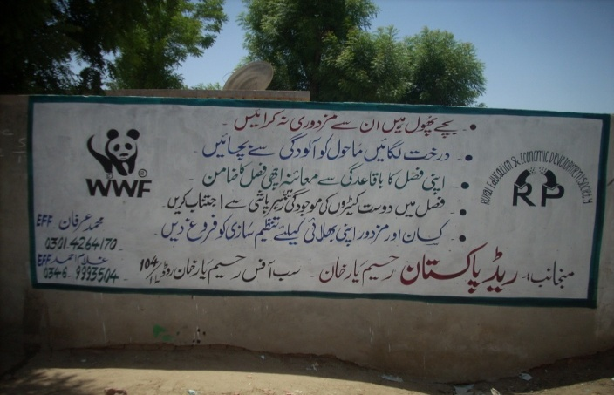

**7.15-Peer Review:**

It is participatory design process to reflect, challenge and learn together about how to improve their efficiency and effectiveness. 91 members of two LGscame together in Chak 121/1L for field visit of the BMP demonstration plot, general discussion, credibility check, participation in the meaning full game and neelam ghar (question answer session).

**Dated**: 10-07-2013 **Venue**: Chak 121/1-L **Total Gatherings**: 91

**Host LG Code:** LG-RPK01-13064 **Guest LG Code**: LG-RPK01-13063

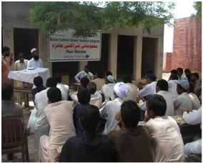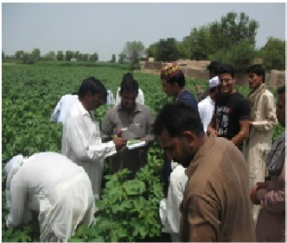

***Objective:***

* To assess/check the progress, gaps and knowledge related to better cotton production according to criteria of BCI, of both the LGs

***Outputs:***

1. Knowledge and experience shared by the farmers
2. Confidence building among the farmers
3. Physical identification of the useful and harmful insect-pest during field visit
4. Increase in farmer’s interest towards BCI project
5. Health and positive competition among the farmers
6. Farmers will ensure attendance in LG training.
7. BCI production principles and MPCs will be adopted by the farmers
8. Farmers will maintain record properly.
9. Regular field visit by the farmers
10. Farmer committees will be strengthened to resolve their local issues

**7.16-President and Secretary/ Scribe Training**

**Date**: 11-7-2013 **Venue**: 121/1-L **Total Gatherings**: 78

**Objectives:**

* To enhance the capacity of President and secretaries to adopt alternate source of income for better living standard.
* To train the scribes for self assessment about BCS implementation.

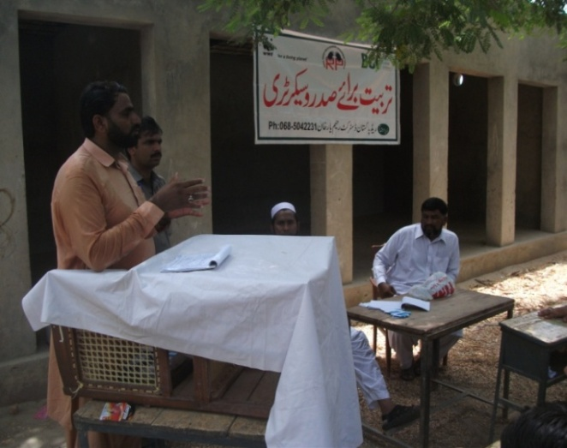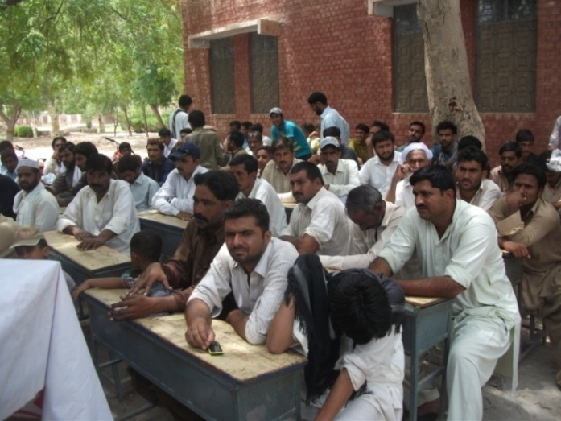

**7.17-Field Staff Self Assessment Training:**

**Self-assessment** is ongoing process of looking at oneself in order to assess aspects that are important to one's identity. It is one of the motives that drive self-evaluation, along with, self verification and self-enhancement.

**Date**: 8-7-2013 **Venue**: REED-PK Sub office Khanpur **Total Participants**: 22

**Objectives of Self Assessment:**

To evaluate BCI farmers that at what position they are now and how much gaps are in their knowledge and practices related to better cotton production. **Annexure**

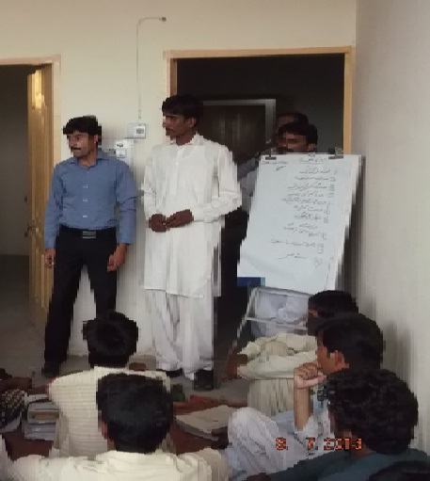

**Results:**

By conducting Training knowledge of the field staff was evaluated, Interest developed and they learned by participating in competitive environment and also by getting training from WWF-P staff.

**7.18-Decent Work Activities**

REED-PK under the guidelines of WWF-Pak-RYK and Khan pur office and his past experiences once again started implementing successful techniques of Better Management Practices for improved farming practices, improved agricultural extension techniques, Decent Work criteria of Better Cotton Initiative under its cotton work through participatory approaches.

**Main Activities:**

* Baseline survey of Decent Work UC 45/P
* Establishment of DWC
* Networking with other stakeholders
* Awareness sessions about Health & Safety
* Awareness sessions about importance of CNIC, Child Rights
* Selection of Women for kitchen gardening
* Printing and Publication of IEC (Information, Education and Communication) material
* Establishment of Child Right’s Club
* Besakhi Mela for promotion of local culture

Baseline Survey regarding Decent Work:

A Baseline Survey gathers key information early in a project so that later judgments can be made about the quality and development results achieved of the project. Keeping in view the importance of Baseline Survey as the first step in the project, REED-DWFF conducted baseline survey in Chak 45/P-Jinnah Colony of 5 model villages UC 45/P Tehsil Khanpur district Rahim Yar Khan.

**Establishment of Decent Work Committees*:***

After the baseline survey REED-DWFF established seven women Decent Work committees to promote decent work in the target areas consisting of 70 members.

**Networking with other GO’s/NGOs/INGOs:**

DW team conducted meetings with the GOs/NGOs/INGOs and shared objectives and activities regarding the promotion of Decent Work.

|  |  |  |  |  |  |
| --- | --- | --- | --- | --- | --- |
| **Sr.#** | **Name** | **Designation** | **Organization** | **Objective** | **Outputs** |
| 1 | Mr. Imran Javaid | Regional Program Head | HDF | To share the objectives and activities regarding DW | HDF committed to collaborate with REED for the promotion of Decent Work  HDF will support for micro-finance through Khushali-bank  HDF will support by organizing medical camps, Health awareness sessions etc. |
| 2 | Mr. Muhammad | Executive Director | Council for Social Development | To share the objectives and activities regarding DW and develop collaboration for raising awareness regarding importance of CNIC and Voter education | CSD along with the collaboration of AGAHE and Un-Women conducted awareness sessions in different village of UC-45/P Tehsil Khanpur |
| 3 | Miss Najma | Field Consultant | Micro-Finance Bank | To share the objectives and activities regarding DW  To develop linkage for providing micro-credit to the DW groups established by REED | Field Office visited the groups and finalized five members for support after completing the basic requirements and records |

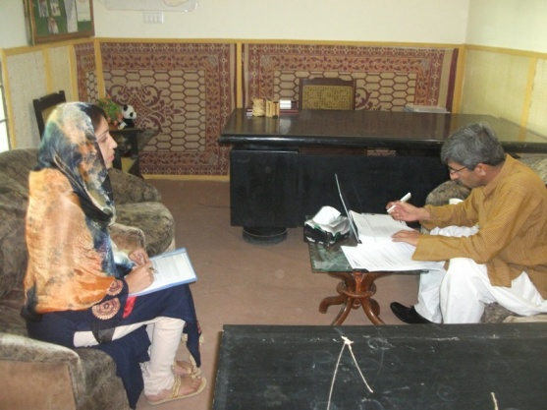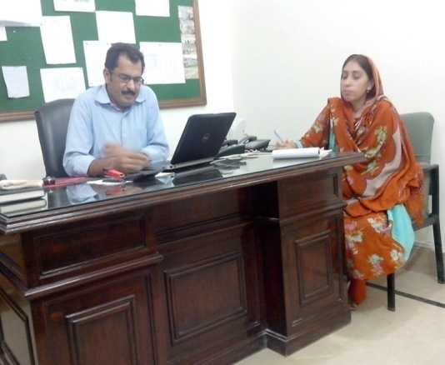

Figure: Mr.Imran Javaid RPH of HDF is appreciating the Decent Work Activities.

Figure: DWFF‘s Meeting with Mr.Razzaq Executive Director of CSD.

***Kitchen Gardening Training and Seed Distribution*:**

Vegetable gardening, especially organic gardening, provides all those benefits, but also allow people to enjoy an healthy activity, fresh herbs, salads and vegetables, reduce the supermarket bill, share the bountiful crops with family, friends and neighbors and, dry or freeze some vegetables for the winter, etc. A garden also provides a great environment for the wild life.

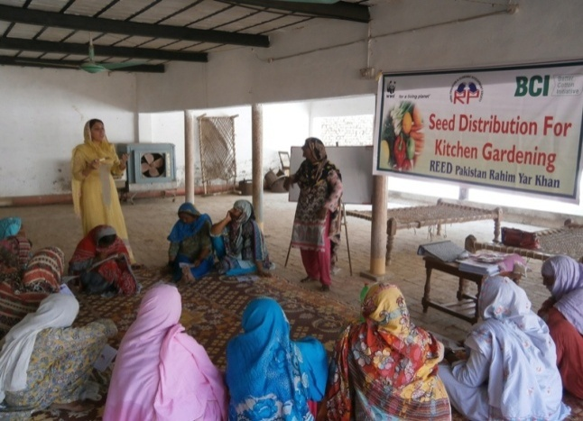Kitchen garden is a device to grow vegetables on a small plot of land. It is delightful hobby and can be pursued at homes or in school. Develop a taste for kitchen gardening and it will stay in your life. In order to preserve health and prevent malnutrition, REED-Pk plan to introduce kitchen gardening in the target areas grow fresh and clean vegetables and make them a part of our daily diet. Keeping in view its great importance DWFF identified 50 women for distribution of vegetables seeds after their training or capacity building.

**Facilitator:**

|  |  |  |
| --- | --- | --- |
| **Sr#** | **Name** | **Designation** |
| **1** | **Zakia Malik** | **DWFF** |
| **2** | **Shamsa Mudaser** | **DWFF** |

**Model Villages:** Chak # 45/P, Chak # 102/1L, Chak # 110/1L, Chak# 100/1L Chak # 115/1L

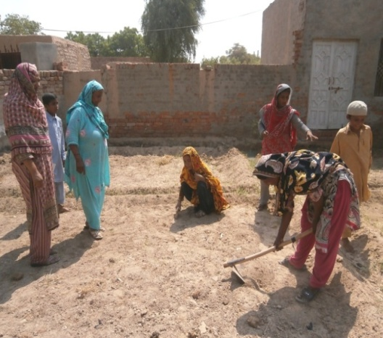

**Objectives:**

* To introduce Kitchen Gardening to minimize poverty to the rural women.
* To provide know how about preparation of land for Kitchen Gardening.
* To develop skills how to grow and what to grow vegetables in Kitchen Garden.
* To facilitate the women farmers with seeds for development of Kitchen Gardening.

***Topics covered during training:***

* 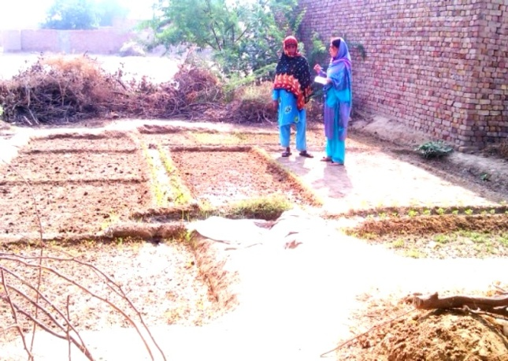Economic importance of kitchen garden
* Selection of kitchen gardening place and its care
* Selection of seeds
* Sowing methods
* Techniques of organic farming
* Preparation of organic manure
* Protection against pests before and after sowing seeds.

**Output:**

* **50 participants understand the concept of Kitchen Gardening and its importance in income generation.**
* **Understand how to manage kitchen gardens using environment friendly farming practices**
* 50 kitchen gardens established ie. 50 families Malnutrition level will be reduced Participants get Employment generated Idea
* 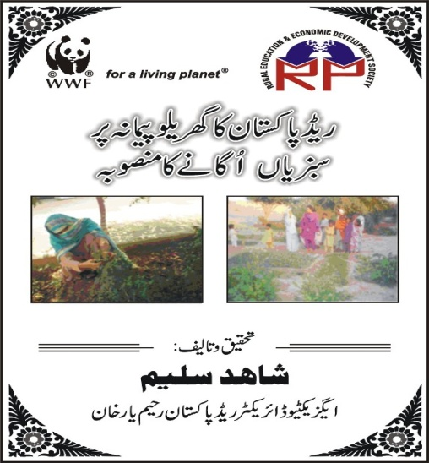Rural income enhanced and females are encouraged to start thinking for them and to take greater responsibility for their own health and well-being. They are given confidence and moral support, so that they can challenge any unfair treatment themselves.

**Development of IEC Material:**

DW Team has developed IEC material for importance of Kitchen Gardening. The Broacher has carrying different types of messages and methods to grow vegetables with the quantity of seeds at home level. This material will be distributed among the females during the kitchen gardening training to achieve good results and maximum production of vegetables. It will also help for spreading the message to wider population.

***Awareness Raising Sessions to Promote Decent work***

The main aim of community awareness programs is to make the community more informed, alert, independent and capable of participating in all activities. The awareness will not only promote community participation but also enable them to understand the following:

***Objectives:***

* To create awareness in the community females about the basic message of BCI regarding Decent Work and to enhance living standard by sharing healthy practices and safety precaution from the unhealthy routine.
* To introduce participants about importance of safe & clean drinking water, Sources of water and how water can be contaminated, When & where hand should be washed, Water born & General diseases, General Hygiene ( personal & environmental hygiene)

The REED-Pk focused following decent work indicators and monitoring instruments as part of its decent work programme.

|  |  |
| --- | --- |
| * Employment opportunities | * Fair treatment in employment and at work |
| * Unacceptable work | * Safe work environment |
| * Adequate earnings and productive work | * Social protection |
| * Decent hours | * Combining work and family life |
| * Stability and security of work | * Social dialogue and workplace relations |

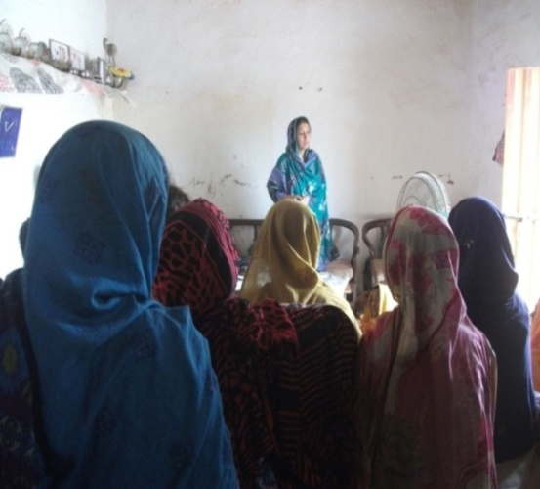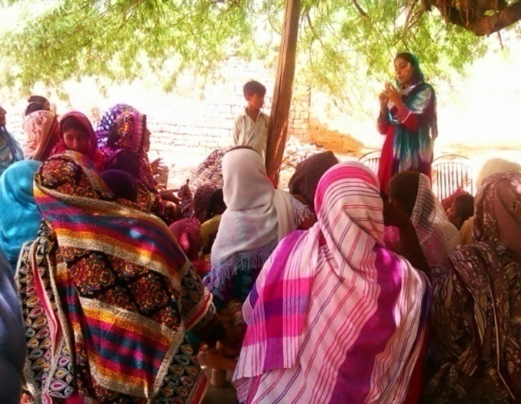

Figure: DWFF is conducting session about the child Labor.

Figure: DWFF is conducting training regarding Child labor in Chak No. 102/1L

**Outputs:**

|  |  |
| --- | --- |
| DWC members participated in the meetings | 55 |
| Number of children transferred to education | 123 |
| Number of poisoning accidents for children at LG level identified | 06 |
| Number of family workers guided to have new CNIC and its importance | 788 |
| Number of members got training regarding DECENT Work (Spray man training, cotton picker’s women training, LHV’s training etc) | 988 |
| Child Right’s Club established | 06 |
| Vegetable seeds distributed among the females | 50 |
| Women members got loan from micro-finance bank | 05 |
| No. of awareness sessions for Children members of Child Rights Clubs | 11 |
| Children members participated in the awareness sessions | 198 |
| N. of women got new CNIC | 302 |
| Families involved in white/mud wash | 29 |

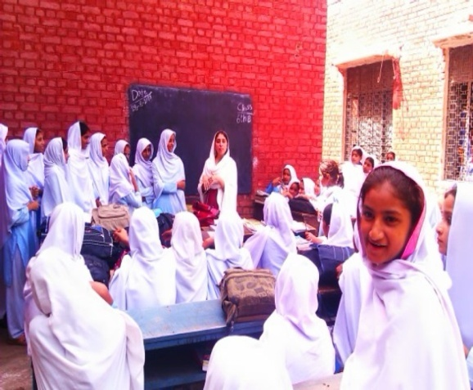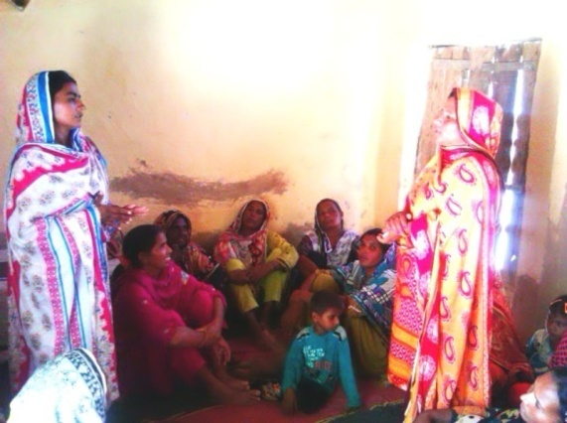

Figure Students of GGMS 45/PP during the awareness session

Figure Women during the meeting with the representative of micro-finance bank

***White Wash/Mud Wash Campaign:***

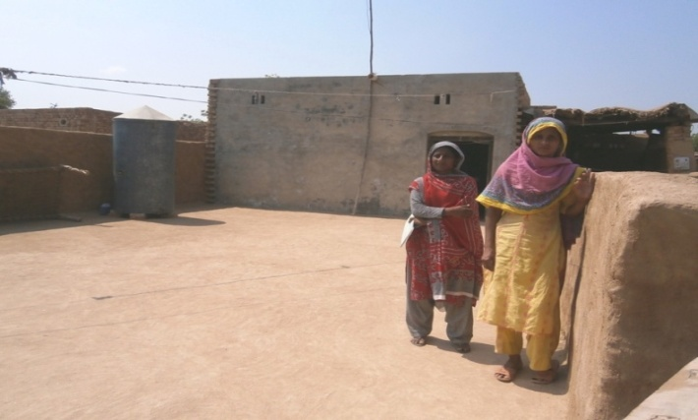In an effort to raise awareness about the need for cleanliness among village residents, the local people have introduced the Mud Wash awareness in the alternative of white wash. As people of the villagers not have many resources to paint or even white wash therefore DWFF gave an idea to the community females to clean their houses by using Mud.

**Promotion of Culture and Peace in Beskhi Mela :**

On 19th April 2013 REED organized Beskhi Mela in Chak 111/1L Uc 45/P in which almost more than 400-450 farmers participated

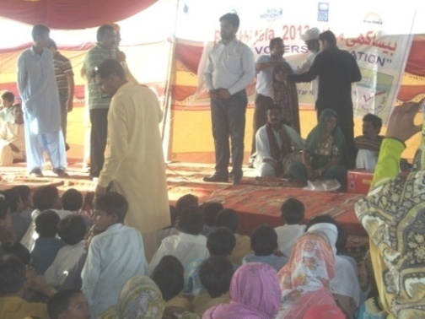

**Important glimpse:**

* The wheat harvesting celebrations in the field really a wonderful.
* Performance of folk music fascinated the audiences of the festival
* The purpose of holding such artistic and cultural programs during the festival is to show cultural similarities among the communities.
* Performance of traditional music and songs, some handy craft exhibitions have been established to visually display these cultural similarities.

Figure: Mr. Muhammad Asif Senior Project Officer (WWF-Pk) is addressing on the Besakhi Mela .

* Another purpose for holding this festival is to bring the youth together and give them the chance to share their common cultural heritage values, promotion of peace and inter-faith harmony.
* Farmers appreciated the partnership of REED and WWF-P with farmers throughout the year which was initially only for cotton season.

**Poster/Painting Competition:**

Environmental crises especially pesticides effects have been occurring worldwide. It is needless to say that the adults, who are active in the first line of society, must take initiatives to solve these problems. At the same time, it is adults’ responsibility to tell children the importance of the environment and teach them how to protect the environment. DW team is aware of that all children are born equal. But cultural, social, economic and other backgrounds make them different.

**Title *“Chemicals Pesticides Impacts on Environment and Children Health “***

**Objective**: To raise awareness on negative effects of chemicals/pesticides and would lead to greater understanding and support for minimizing pesticides use for the protection of environment, healthy living and sustainable development.

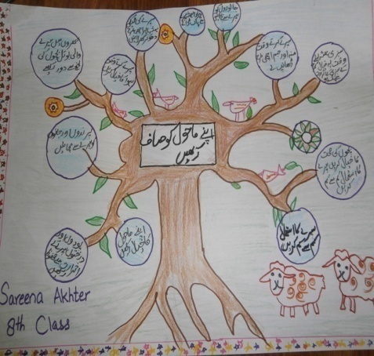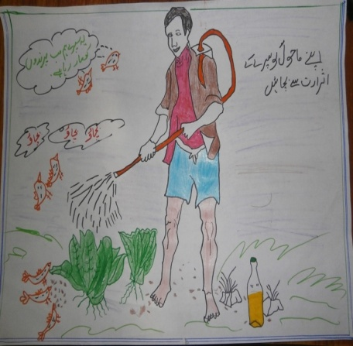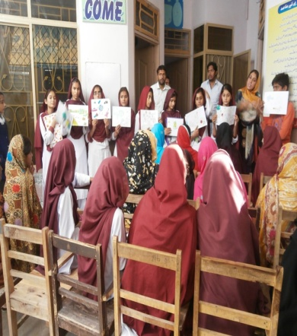

**Methodology:**

Activity conducted with the collaboration of District Education Department in addition EDO education circulated the letter to the school heads for this activity.

* Teachers and head teachers were responsible for this activity in their school further Field Facilitator (Decent Work) also monitored the activity at school level.
* The excellent pictures for school representation with art teacher signature and head teacher sign and stamp collected.
* REED along with WWF and Education Department finalize 1st, 2nd, and 3rd positions.

**7.19-Spray man Training:**

Insecticides/Pesticides are the chemicals used to control the crop losses by cidal phenomenon (killing) the insects/pests harmful for crop and such chemicals are playing a vital role in yield and crop production. The ingredients of these chemical pesticides are not only lethal for target arthropods but also for human beings. 133 participants participated 4 training sessions in which the main topics were general pesticides, classification, symptoms of side effects of poison, treatment, methods of application, time of application, precautionary measures during application, storage and disposal of pesticides, calibration of spray machines. The facilitators for training were Mr. Muhammad Riaz DO-REED-Pk and Mr. Ghulam Ahmad, EFF.

**Objectives:**

* To enhance the capacity of the Spray mans regarding the proper techniques of the application
* To avoid hazardous effect during pesticide application.

**Methodology:**

* Pre and Post test
* Participatory sharing/lecture
* Experience sharing
* Demonstration

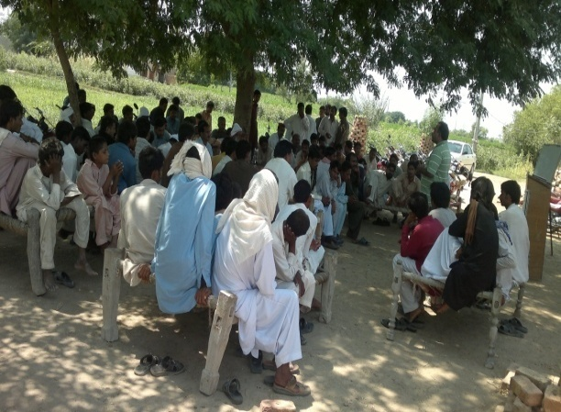**Outputs:**

* The capacity of 133 participants enhanced regarding proper methods and techniques of pesticides application.
* The crop to be treated (density, height, field, greenhouse, etc).
* he application equipment.
* The application conditions (weather, topography, etc).
* 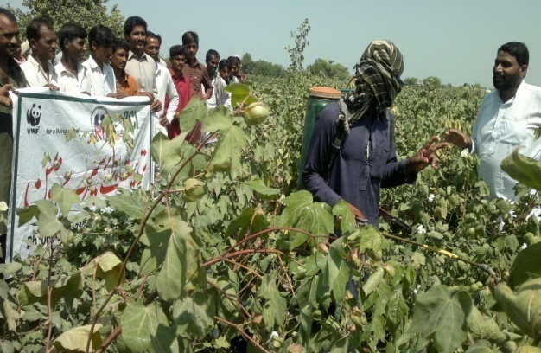The use of suitable protective equipment (PPE)
* The duration of the treatment process.
* Calibration and spraying/application techniques.
* The participants become aware about the health hazardous affects of chemical pesticides i.e. acute symptoms of pesticide poisoning include headaches, vomiting, tremor, difficulty breathing or respiratory depression, loss of consciousness, seizures and death.

**7.20-Worker Families Training:**

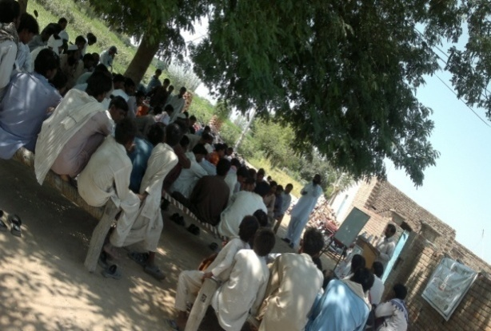Women, children and men are the waged agricultural workers who labour in the cotton crop fields to produce better cotton. They are employed on small- and medium-sized farms and are waged workers because they do not own or rent the land on which they work nor the tools and equipment they use and so are groups distinct from farmers. It has been observed that in the area worker farmers are poorly organized. Training for worker families were organized in which 135 participants participated.

**Objectives:**

* To raise awareness among the worker families about their rights and enhance living standard by adopting alternate source of incomes and managing things properly.
* 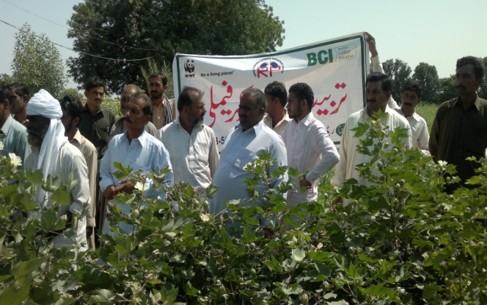To raise awareness regarding hazardous work done at farm and especially the children who are involved in such type of activities.

**Main Topics:**

Basic labor Rights, Health and Safety, DW components and resource management

**Methodology:**

* Pre and Post test
* Participatory sharing/lecture
* Experience sharing

**Outputs:**

* 135 Participants become aware about their basic rights, decent work components during working on the farm.
* Participants committed protection of all children from exploitation in agricultural and rural settings.
* Participants ensured that children below the minimum legal age (18 years) of employment will be withdrawn/removed from work on farms and fields.
* Participants committed to organize them so that they can negotiate with their employers for better working conditions.
* Children’s were compelled to go to school.

**7.21-Rickshaw Announcement**

According to the work plan at 9 :00 am rickshaw announcement was started with the introduction of WWF-P as a nature conservation organization which has been working since 1970. It has many projects in Pakistan but in Rahim Yar Khan it is working on better cotton aiming to change the mindset towards betterment of socially, economically and environmentally.

**Objectives:**

* Wider dissemination of BMP messages

**Movement Directions:**

Chak37/P,38/P,44/P,45/P,106/1L,107/1L,108/1L,109/1L,110/1L,111/1L,112/1L,100/1L,101/1L102/1L,103/1L,99/1L,98/1L,121/1L,120/1L,122/1L,124/1L,125/1L,126/1L,97/1L,94/1L,95/1L,33/P

**Methodology:**

* Facilitators (FF/EFF/DO) through loud speakers use to announce BMP messages to the masses (less time more coverage)
* Each FF announced BMP messages in their LGs or target areas i.e.
* Crop should be irrigated when it is needed by observing the water symptoms.
* Fertilizer should be applied according to the need of crop and after soil sampling.
* To control White fly and mites use 50 gram detergent and cold water spray. To control leaf curl virus spray zinc + boron + magnesium.
* Reduce the child labour and forced labour.

**Output:**

This message was delivered to 15000 farmers tentatively.

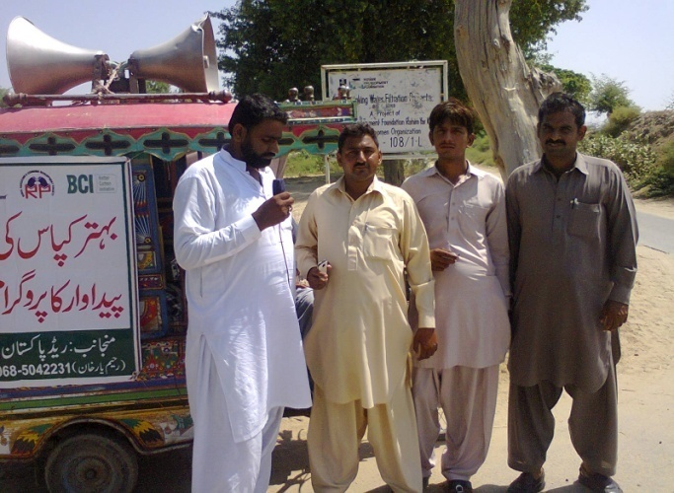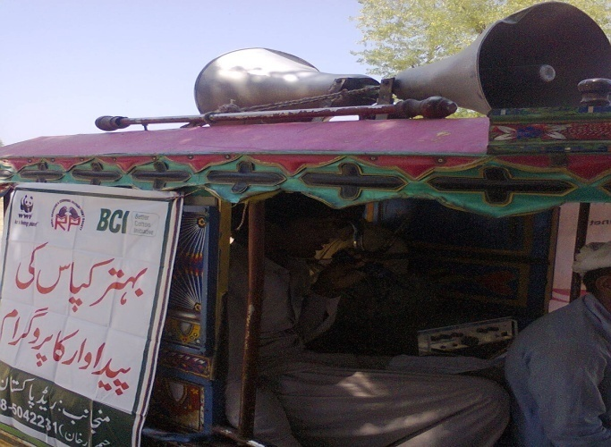

**7.22-Cotton Picker’s Training:**

Cotton is an important cash crop of Pakistan and its produce is obtained in the form of seed cotton, cotton lint and cotton seed. Only those growers, who maintain its quality and high standards, get higher prices. Growers have achieved yield targets but have not taken steps to emphasize on the quality control procedures. Keeping in view the importance of proper picking REED-Pk with the collaboration of WWF-Pakistan conducted one day trainings of cotton pickers.

**Objectives:**

* To build up the capacity of pickers and to train them about better cotton.
* To introduce the cotton pickers with the latest techniques and methodology of cotton picking to maintain the quality of the output from field.
* To enhance and improve the skills of cotton picking for better quality of the crop and get its maximum production.
* To provide knowledge about the health and safety measurement for cotton picking females.
* To facilitate the women cotton pickers with Safety equipment i,e Mask and Gloves to avoid the pesticides effects on their health.

**Methodology:**

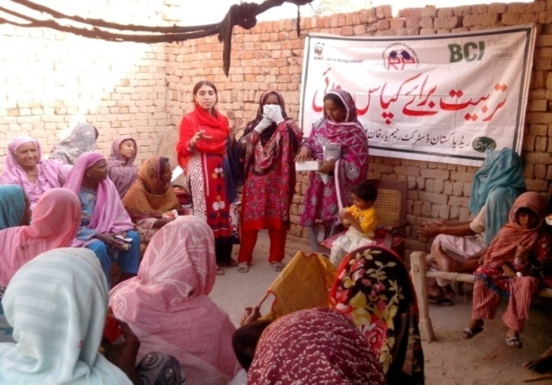During picking DW Field Facilitators trained them and told them how they can minimize trash and the better way of picking and what precautionary measures they should adopt for health and safety.

* Pre and Post test
* Participatory sharing/lecture
* Experience sharing

**Health and Safety:**

Basic facilities of health and safety in case of hazard work are a main issue. As they are front line workers so, they suffer due to unavailability of such kind of facilities. Through participatory approach basic things necessary for their health and to improve their living standard were discussed to create awareness and also sensitize them to take care of fresh and clean water utilization, basis treatment from nearby doctors and protective measures to improve the health.

**Facilitator:**

|  |  |  |
| --- | --- | --- |
| **Sr#** | **Name** | **Designation** |
| **1** | **Zakia Malik** | **DWFF** |
| **2** | **Shamsa Mudaser** | **DWFF** |
| **3** | **Rubina Shad** | **LHS (BHU 45/p)** |

**Conclusion of the Training:**

Facilitators conducted training and throw light on the importance and significance of the training.  
She shared with the participants that females have better picking skills then the males , which is the main reason of the job of cotton picking is assigned to female sect of the population. But, such rural females doing the job of picking by ignoring maintains, cleanness and quality of cotton. For this sort, training of cotton picking women is essential so that impurities free picking of cotton is to be made. To obtain clean cotton and to maintain its standard safe and sounds, picking female are required to collect cotton by using muslin cloth. To avoid impurities such as dust and trash mixing in the cotton, the picking should be done from lower side towards top this step will lead to clean cotton picking.

The picking of cotton should be done after drying of wetness and dew from the crop.

She added that in our rural side, cotton picking is done by manual methods, which must be done when more than 50% bolls are opened. The variety wise picking should be done and kept variety wise separate in the bundles.

Miss Rubina Shad Lady Health Supervisor BHU 45-P appreciated the REED Pk team to educate and aware the females for the cotton picking techniques. However she also described health hazards effect of pesticides in the cotton picking season especially on the health of pregnant females and mothers of infant. She also highlighted the cotton picker’s women behavior in the field and effects of pesticides on their health

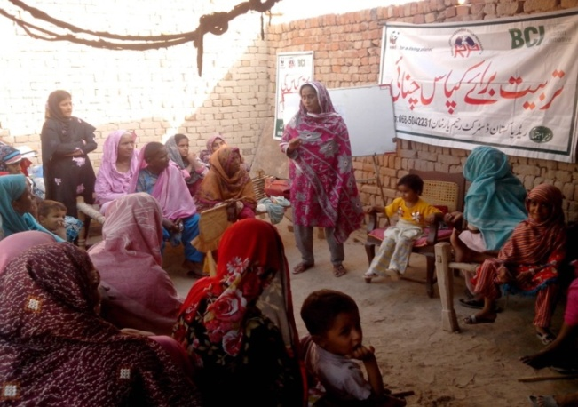

However, all of females had a very clear idea that cotton picking and pesticides is harmful to their health but participants admitted that they never apply any safety measurement during cotton picking.  In this regard DW FF distributed Masks and Gloves among the all participants for the protection of pesticides effects.

During training the participants asked various questions about the cotton picking and also shared their experience in the field.

**Outputs:**

* Capacity of 199 women and 23 men enhanced regarding clean picking, how to minimize trash, rights of cotton pickers, health and safety measures during picking.
* Cotton pickers become aware about the proper timing of picking and its storage.

**7.23-Credibility Checks:**

As per BCI requirement, IP will conduct 10 % CC him to verify the Self assessment conducted by farmers. It was planned 80 % before harvesting and 20 % during harvesting. So, CCs were planned and were conducted with the coordination of WWF-P RYK team. Detailed is attached as **Annexure # 4.**

**7.24-2nd Credibility by BCI**

**BCI Representative:** Mr. Zeeshan Tariq

**LGs:** LG-RPK-13013, LG-RPK-13070, LG-RPK-13068

**Date:** 18-19 July

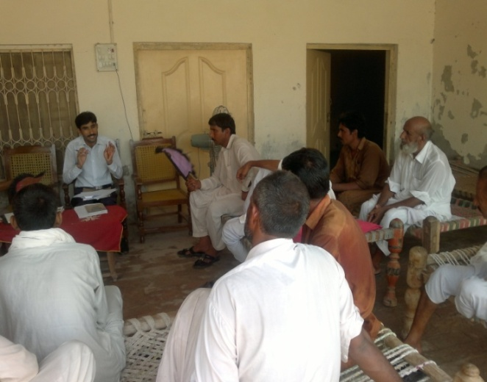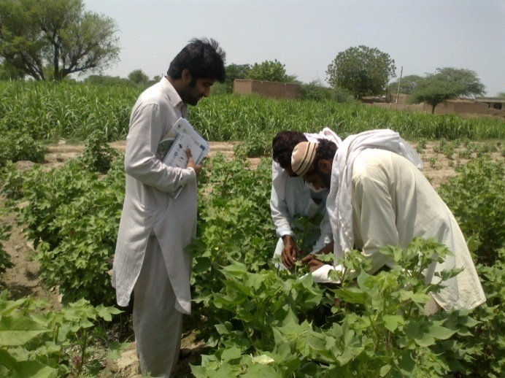

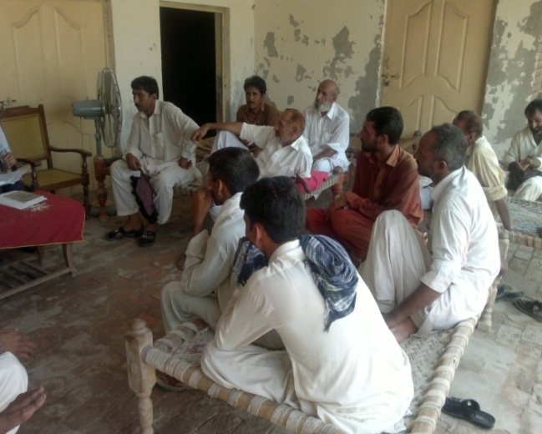7.25- 2nd party by IP

During July 80% CC has been conducted in OVOF and LFEs by WWF-P (IP).

Parts of CC

* Farmers CC about BCI Field implementations
* Worker interview
* FF interview

**7.26- 3rd Party by BCI**

3rd Party verifier has selected PU-RYK-RPK02 for verification They have selected three LFEs.

**Verifier:** SGS **Date:** 1-2 july-2013s

**LFEs:** PU-RPK02-13063, PU-RPK02-13067, PU-RPK02-13070

**Methodology:**

1-Farmer interview

2-Worker interview

3-Female worker interview by visiting them

4-FF interview (Separate in field)

5-Management review

6-DO interview

7-FP interview

8-EFF interview

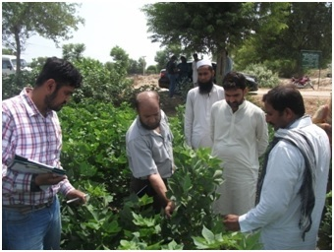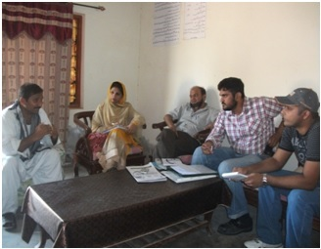

Figure Team during interview with LFE

Figure Team during field visit

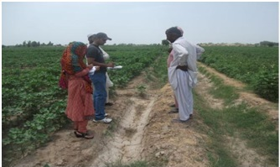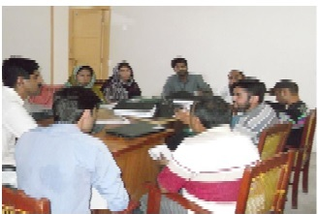

Figure Team during Worker interview

Figure Team during de-briefing session with REED staff

***7.27-Wheat Collection (A step toward Sustainability)***

Sustainability is based on a simple principle: Everything that we need for our survival and well-being depends, either directly or indirectly, on our natural environment.  Sustainability creates and maintains the conditions under which humans and nature can exist in productive harmony, that permit fulfilling the social, economic and other requirements of present and future generations. In this regard every PU has planned to collect 40 monds wheat from farmers as an Advisory service as farmer must understand that how much is the importance of FF advisory because they have paid for the service. The deadline was 25 May and with the efforts and devotion of REED-PK Staff to their work has met the deadline and fulfills the target before deadline. REED-PK has won 2nd prize in Wheat Collection.

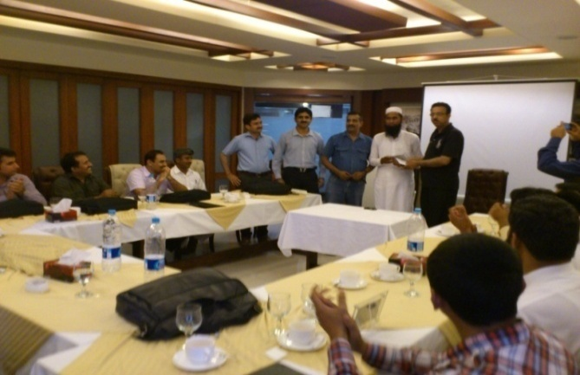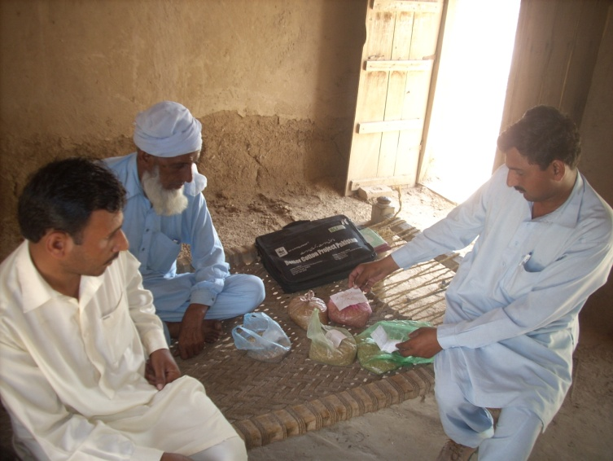

Figure REED Field Facilitator during collection of wheat

Figure Mr. Arif Makhdoom during presenting shield and Cash price to REED Documentation Officer

**8-Data Analysis**

REED-Pk management and field staff i.e. DO, EFF and FF conducted regular field visits of target areas. Keeping in view improving farmer’s knowledge and yield in addition reducing Soil, Air and Water pollution REED-Pk team worked with full commitment and dedication focusing better management practices (BMP). The aim of the initiative was to introduce Better Management Practices (BMP) that can optimize productivity and ensure high benefits for cultivators, with minimum possible damage to the environment. With a methodology OVOF through 17 Field Facilitators, 3 EFF, 2 DWFF and one District Agriculture Officer, Focal Person who visited farmer’s fields, conducted meetings with the Learning Groups (LG’s), monthly gatherings, trainings of decent work and gave them significant recommendations/advisories regarding BMP of cotton to get maximum outputs. To streamline the activities monitoring team worked efficiently and prepared their report for future planning. The underline data is analysised as each FF got data of 100 control farmers of its target 99 LGs and 3899 farmers. The data has been analysised in a way that 100 control farmer’s data analysised against the 100 farmers of a PU selected on random bases.

**Control Farmer and BCI Farmer Field Analysis:**

BCI-farmer and Control Farmers were selected with same variety, same seed rate and sowing date. BCI-farmers plot where decisions regarding crop management were to be made through Cotton Eco System Analysis (CESA) using participatory approaches by the FF, EFF/farmers while Control Farmer Plots (CFP) where decisions were to be made by the farmers themselves who established.

**Practices & Cost Benefit Analysis of BCI-Farmer & Control Farmer**

**Use of synthetic Fertilizer:**

BCI farmer applied 260 Kg Urea, 40 Kg DAP, 101 kg CAN, 1.5 Kg TSP, 10 Kg SSP and 7709 Kg FYM per hectare while Control Farmer applied 381Kg Urea, 140 Kg DAP, 72 kg CAN, 0 Kg TSP, 0 Kg SSP and 0 Kg FYM per hectare. At general BCI farmer spent 22580 Rs./hectare for synthetic fertilizer and Farm Yar Manure, while Control Farmer spent 30801 Rs./hectare for synthetic fertilizer, on an average BCI-Farmer saved 8221 Rs./hectare. In the project area total amount saved under this head is 201883097 Rs.

Control farmers used excessive Synthetic fertilizer due to some misunderstanding and lack of knowledge

* About nutrient requirement
* Critical growth stages of cotton crop
* Formulation of Synthetic fertilizer
* Micro and macro nutrient deficiency Symptoms
* Proper time and method of application
* Misconceptions that yield are correlated with higher dose of fertilizer application.

BCI-farmers saved their wealth/money/assets and got better results due to knowing nutrient requirement of the cotton crop, methods of application, Micro and macro nutrient deficiency symptoms, presence of nitrogen and phosphorous ratio in each bag which contributed for better yield. Reduction in Synthetic fertilizer application also ***decrease soil and water pollution*** as nitrate is carcinogenic and this also disturb the natural soil environment, as a result we have ***conserved Nitro-somonas and Nitro-bactor naturally occurring bacteria in soil for nitrogen absorption from atmosphere.***

**Use of Pesticides:**

BCI-Farmers applied total pesticide 4.3 kg/hectare while Control Farmer applied 9.6 Kg/hectare. At a general 5.3 Kg/hectare pesticide saved by the BCI-Farmer through IPM and applying BMPs.

There for in the target area BCI-farmers saved 130152 Kg/24557 hectare.

BCI-Farmers applied pesticide of Rs. 5955/hectare while control farmer applied pesticide of Rs. 8275/hectare in total BCI-farmers saved 56972240 Rs/24557 hectares.

Keeping in view the environmental degradation, due to less use of synthetic pesticides by the BCI-Farmers there is decrease in soil, air and water pollution which also conserve our naturally occurring beneficial insects. Control farmers applied more pesticides because they don’t know

* Differentiation between harmful and beneficial insects.
* Mode of action of the pests
* Familiar with CESA (Cotton Ecosystem Analysis) technique.
* Relay on synthetic pesticides, no knowledge about botanical, biological and cultural control of pests.

**Water Conserved in Irrigation Practice**

Graph shows that BCI-Farmers applied 3162 cubic meter irrigation water while Control Farmer applied 3381 cubic meter irrigation water per hectare. Therefore BCI-Farmer saved 219 cubic meter irrigation water/hectare or at general in the target area farmers saved 5377983 cubic meter irrigation water/4186 hectares.

It illustrates that Control farmers applied unnecessary water which was quite un-necessary and wastage of precious water due to

* Lack of knowledge about crop water requirement and critical growth stages with respect to water requirement.
* No proper water scouting before irrigation
* Conventional habit of flood irrigation
* Ample water available during the season

So in this way they are wasting this precious blessing and causing soil erosion due to excessive irrigation. ***While BCI-farmers conserve the enormous natural resource, water and also conserve the soil from erosion through un-necessary application of irrigation water.***

**Seed Cotton Yield**

The data shows about seed cotton yield of BCI-farmers and Control Farmers in 2013. The average Seed cotton yield of Control Farmer’s yield was 1818 kg/hectare while BCI-farmer was 2324 Kg/hectare, which is 22 % more or BCI-farmer’s yield increased on an average 506 kg/hectare.

**Net Income per Hectare**

As the data shows comparison between net income per hectare of BCI-Farmers & Control farmers in 2013. Control farmer’s income was **139986 rupees** per hectare while BCI-farmers income was **178948 rupees** per hectare from their cotton crop which was 53 **%** more than control farmer or BCI-Farmer has **38962 Rs.** more income per hectare.

**9-Conclusion:**

In year 2013, **OVOF** activity was started in the month of March and ended in the month of December. Field Facilitators, Expert Field Facilitator and Project In-charge were directly involved in the implementations of BMPs at farmer’s field level. Farmers were facilitated about their cotton crop issues on weekly bases as well as capacity building programs regarding the Decent Work was also part of the project. Learning by doing approach or pull and push method was adopted as a result not only farmers were advised but we also learnt from their own experiences. Evaluation has been focused on better management practices and cost benefit analysis of same farmers in BMP & Control farmers 2013. Analysis covered Better Management Practices (BMPs) done during cotton season 2013. The results of this study are discussed about which are very encouraging.

**10-Annexure:**

***List of Staff participated in the training***

|  |  |  |  |  |  |
| --- | --- | --- | --- | --- | --- |
| **Sr.** | **Name** | **S/O** | **Designation** | **Cell no** | **Address** |
| 1 | Shahid Saleem | Anayat Saleem | FP | 0345-8011699 | Jinnah Park St.# 16 RYK |
| 2 | Qazi M Rizwan | Qazi Wahid Bakhsh | Ao | 0333-74703899 | Pak Motr Qaid e Milat Rood Khan pur |
| 3 | M Asghar Qazi | Muhammad Akber Qazi | EFF | 0301-7881448 | Qureshi Chok MuzafrGarh |
| 4 | Ghulam Ahmad | Haji Jind Wada | EFF | 0346-9993504 | Tranda Sawy Khan, RYK |
| 5 | Saeed ur Rehman | Abdul Rehman | EFF | 0342-8842059 | Chak no 82/A,P/o Liaquat pur |
| 6 | Muhammad Irfan | Iftikhar Ahmad | FF | 0301-4264170 | Chak no 100/1L,Khan Pur RYK |
| 7 | Muhammad Khalil | Karam Hussain | FF | 0345-8028662 | Kot Smab, Raheem Yar khan |
| 8 | Abdul Rasheed | Ali Muhammad | FF | 0332-7359254 | Bismilha Pur,Raheem Yar Khan |
| 9 | Abdul Hakeem | Jam Punu | FF | 0344-7258729 | Mauza Kamil,Lar Liaqat pur RYK |
| 10 | Muhammad Asghar | Saliha Muhammad | FF | 0346-9993477 | Chak 72/A,Tehs Liaqat pur |
| 11 | Sajid Basheer | Muhammad Basheer | FF | 0345-8143249 | Chak no 69/A,Tehs Liaqat pur |
| 12 | Zulfqar Ali | Muhammad Sarwar | FF | 0301-6782076 | Chak no 104/1L,Tehs Khan pur |
| 13 | Fida Housain | Khuda Bux | Activist | 0302-6823514 | Liaqat Pur |
| 14 | Sarmad Javeed | Muhammad Anwar | Activist | 0342-7100426 | Liaqat Pur |
| 15 | Muhammad Saeed | M Saleem | Activist | 0346-6897898 | Chak no 97/1L,Tehs Khan pur |
| 16 | Muhammad Zafar | Noor Muhammad | Activist | 0345-8034756 | Chak no 121/1L Tehs Khanpur |
| 17 | Tanveer Asghar | M Asghar Hussain | Activist | 0342-7247147 | Peer channan punnan |
| 18 | Naimat Patrus | Inayat Pehlwan | Activist | 3996873257 | Liaqat Pur |
| 19 | Tahir Martan | Moula Bux | Activist | 0321-6717116 | Chak no 116/1L,Tehs Khan pur |
| 20 | Muhammad Ramzan | G Muhammad | Activist | 0346-8461383 | Chak no 125/1L,Tehs Khan pur |
| 21 | Muhammad Asrar | Nisaar Ahmad | Activist | 0345-4479890 | Chak no 100/1L,Tehs Khan pur |
| 22 | Afzaal Basheer | Basheer Ahmad | Activist | 0315-8022123 | Chak no 123/1L,Tehs Khan pur |
| 23 | Abdul Lateef | Ghulam Qadir | Activist | 0307-7619014 | Chak no 108/1L,Tehs Khan pur |
| 24 | M Bilal | Ghulam Nabi | Activist | 0341-6971102 | Chak no 102/1L,Tehs Khan pur |
| 25 | Ghulam Fareed | M Shafiqe | Activist | 0347-7842080 | Chak no 121/1L,Tehs Khan pur |

**Annexure: List of Beneficiaries for Kitchen Gardening:**

|  |  |  |  |  |
| --- | --- | --- | --- | --- |
| **Sr #** | **Name** | **Parentage** | **Village** | **Contact No.** |
| 1 | Suraya BB | M.Ashraf | Chak 45-p | Nil |
| 2 | Shareefan BB | M.Nawaz | Chak 45-p ( Jinnah Colony) | Nil |
| 3 | Jeejan Mai | Keseriya | Chak 45-p ( Jinnah Colony) | 0335-2130730 |
| 4 | Shameem Akhter | M.Nawaz | Chak 45-p | Nil |
| 5 | Maqsooda BB | Serfaraz | Chak No.116/1L | Nil |
| 6 | Sumaira Shafiq | Shafiq Ahmed | Chak No.116/1L | 0321-3481505 |
| 7 | Irshad Munawar | Munawer Ahmed | Chak No.116/1L | 0305-38994697 |
| 8 | Kalsoom Devi | Sardar G | Chak No.115/1L | Nil |
| 9 | Gonoori | Kanoora G | Chak No.115/1L | Nil |
| 10 | Meryam Devi | Lalo Raam | Chak No.115/1L | Nil |
| 11 | Shameem Devi | Hukam G | Chak No.115/1L | Nil |
| 12 | Moreen Mai | Jogi G | Chak No.110/1L | 0342-7311618 |
| 13 | Najma BB | M.Aslam | Chak No.110/1L | 0334-73435899 |
| 14 | Hurmat Mai | Kaiser Raam | Chak No.110/1L | Nil |
| 15 | Majeeda | Khadim Hussain | Chak No.112/1L | Nil |
| 16 | Musarat BB | Mushttaq Ahmed | Chak No.112/1L | Nil |
| 17 | Allah Rakhi | Allah Dita | Chak No.112/1L | Nil |
| 18 | Rukhsana BB | Akbar | Chak No.111/1L | Nil |
| 19 | Basheera Devi | Kheeta G | Chak No.111/1L | Nil |
| 20 | Hifza Khalil | M.Khalil | Chak No. 102/1L | Nil |
| 21 | Shazia | M.Ameen | Chak No. 102/1L | Nil |

**Annexure: Detail of Training Sessions**

|  |  |  |  |  |  |
| --- | --- | --- | --- | --- | --- |
| **Sr #** | **Tehsil** | **UC** | **Village/Chak** | **No.Of Participants** | **Topic** |
| 1 | Khan Pur | 45/P | Chak # 110/1L | 21 | Forced Labor Awareness |
| 2 | Khan Pur | 45/P | Chak # 116/1L | 25 | CNIC Importance and Process |
| 3 | Khan Pur | 45/P | Chak# 112/1L | 19 | CNIC Importance & Child Labor |
| 4 | Khan Pur | 45/P | Chak #102/1L | 19 | Health And safety Awareness |
| 5 | Khan Pur | 45/p | Chak # 45/P B | 23 | Health And Safety |
| 6 | Khan Pur | 45/p | Chak # 111/1L | 17 | Gender Discrimination Awareness |
| 7 | Khan Pur | 45/P | Chak # 107/1L | 23 | Child Labor and CNIC Importance |
| 8 | Khan Pur | 45/P | Chak # 115 /1L | 15 | Child Labor Awareness |
| 9 | Khan Pur | 45/P | Chak # 116/1L | 23 | Child Labor Awareness & CNIC Awareness |
| 10 | Khan Pur | 45/p | Chak # 102 /1L | 23 | Child Labor Awareness |
| 11 | Khan Pur | 45/P | Chak # 45/p A | 20 | Gender Discrimination |

***Annexure: List of Decent Work Committees:***

|  |  |  |  |  |  |
| --- | --- | --- | --- | --- | --- |
| **Sr #** | **Name** | **Parentage** | **Designation** | **Contact N0** | **CNIC No.** |
| **1** | **DW Committee Chak No.45/P** | | | | |
| 1 | Suraya Bibi | Farzand Ali | President | 0346-8429713 | 31303-1138869-4 |
| 2 | Naseem Bibi | M. Ramzan | Vice President | Nil | Nil |
| 3 | Hameeda Bibi | Ghulam Bari | Member | 0301-7439384 | 31303-9135914-6 |
| 4 | Aqlan Mai | Hari Chand | Member | Nil | Nil |
| 5 | Parveen Akhtar | M. Akram | Member | 0308-2999705 | Nil |
| 6 | Jeejan Mai | Keseria | Member | Nil | Nil |
| **2** | **DW Committee Chak No.110/1L** | | | | |
| 1 | Manzoora BB | M.Ashraf | Member | Nil | Nil |
| 2 | Keeko Mai | Bhooro G | Member | Nil | Nil |
| 3 | Shakeela Yasmeen | Shams Deen | President | Nil | 31303-7147622-4 |
| 4 | Moreen Mai | Jogi Gee | Vice President | 0342-7311618 | 31303-1799419-2 |
| 5 | Shahnaz Kousar | M. Iqbal | Member | Nil | Nil |
| 6 | Najma Bibi | M. Aslam | Member | 0334-7343589 | 31303-1348726-6 |
| **3** | **DW Committee Chak No.112/1L** | | | | |
| 1 | Naseem Akhtar | M. Yaqoob | President | 0322-9743512 | 31303-6132781-2 |
| 2 | Shahida Bibi | Khalid Maqsood | Vice President | Nil | 31303-3777999-6 |
| 3 | Musarat BB | Mushtaq Ahmed | Member | Nil | Nil |
| 4 | Shameem Akhter | Matloob Ahmed | Member | Nil | 31301-6408547-6 |
| 5 | Yasmeen Akber | Akber Ahmed | Member | Nil | 31301-13389935-8 |
| **4** | **DW Committee Chak No.111/1L** | | | | |
| 1 | Noor Jahan | Faqeera | Vice President | Nil | Nil |
| 2 | Koyal Mai | Hukam G | Prisident | Nil | 31303-1590828-2 |
| 3 | Zubida Bibi | Hanif Ahmed | Member | Nil | Nil |
| 4 | Bashira Davi | Khaita G | Member | Nil | Nil |
| 5 | Zeenat BB | Haji Amman Ullah | Member | Nil | Nil |
| **5** | **DW Committee Chak No.115/1L** | | | | |
| 1 | Kalsoom Devi | Sardar G | Prisident | Nil | 31301-0584395-6 |
| **2** | Maryam Devi | Lalo Raam | Vice President | Nil | 31301-9112389-2 |
| 3 | Nasreen BB | Roshan | Member | Nil | Nil |
| 4 | Razia Mai | Faqeera | Member | Nil | Nil |
| 5 | Gurya Devi | Hukam G | Member | Nil | Nil |
| **6** | **DW Committee Chak No.116/1L** | | | | |
| 1 | Jameela Pervaiz | Pervaiz Ahemd | Prisident | 0321-6750516 | Nil |
| 2 | Perveen Saleem | Saleem Maqsood | Vice President | Nil | Nil |
| 3 | Kalsoom BB | M.Akram | Member | Nil | Nil |
| 4 | Razia BB | Razaq Ahmed | Member | Nil | Nil |
| 5 | Shameem Roshan | Roshan | Member | Nil | Nil |
| **DW Committee Chak No.102/1L** | | | | | |
| 1 | Sardaran BB | M.Khalil | President | 0301-2125224 | Nil |
| 2 | Perven BB | Abdul Shakoor | V.president | 0308-7625323 | Nil |
| 3 | Khushnood BB | M.Ramzan | Member | 0304-9976615 | Nil |
| 4 | Kalsoom BB | M.Aslam | Member | Nil | Nil |
| 5 | Shareefan BB | Abdul Rehman | Member | Nil | Nil |

**Annexure: Problem Identification Analysis**

|  |  |  |  |  |  |  |
| --- | --- | --- | --- | --- | --- | --- |
| **Problem** | **Causes** | **Effects** | **Actions Proposed** | **1st Year** | **2nd Year** | **3rd year** |
| **Water**   * **inadequate** * **unsafe** | * inadequate infrastructure * lack of rain * water is unclean for drinking * less canal water to fulfill the agriculture needs * under ground water brackish | * must get water from far away * use of unsafe/unclean water * problems with disease * low development | * asking for sponsors to contribute to drilling of boreholes and improvement of distribution system, * Sensitization of farmers for varieties need less water * Water analysis for agriculture use and apply recommendations | 20% | 30% | 50% |
| **Health** | * lack of female doctors and nurses in addition un-availability of proper medicine | * unnecessary death, particularly for pregnant women * Children diseases increasing | * asking for more medical services and staff * Networking with health institutions * Collaboration with HDF for improved health services | 10% | 20% | 40% |
| **Poverty** | * lack of education * poor infrastructure systems * lack of capital | * theft within the village * Children are not going to school * destruction of the environment | * Income generating schemes should be started i.e. rearing of livestock, kitchen gardening, skill development and promotion | 10% | 20% | 40% |
| **Transportation** | * lack of infrastructure systems * poor infrastructure planning | * poor development | * infrastructure maintenance * Selling of agriculture products in groups | 10% | 20% | 40% |
| **Veterinary Health** | * no professionals to show them how to better take care of animals | * No timely vaccines * Less milk and milk products * death of cattle, * low selling price for cattle | * need personnel to advise them * Capacity building of the local young volunteers or training of veterinary assistant * Capacity building of the livestock keepers | 20% | 30% | 50% |
| **Education** | * lack of teachers * lack of teaching materials * Teacher absenteeism | * children lack education * Child labour * Fighting among children | * asking for an institution to bring them teaching materials, improve education facilities through SMCs * VDO should meet with the Head teachers or EDO to minimize the absenteeism | 10% | 20% | 40% |
| **Vocational Training Schools** | * no vocational training schools to learn about skills for sustainable development by the youth | * slows down development, * Unemployment * Women are not involved in skills and passing their time in non development activities | * asking for government or private institution to build them a vocational school | 10% | 20% | 40% |
| **Environmental degradation** | * Lack of fire wood * Lack of capacity of the farmers about proper application of fertilizer, pesticides etc. * Low soil fertility | * Eye and lungs affected due to smoke * Soil, water and air pollution | * Introduction of Bio-gas plants and Fuel efficient stoves * Training of farmers about proper application of pesticides and fertilizer * Introduction of fermenter | 20% | 30% | 40% |

**Annexure # :**

|  |  |  |
| --- | --- | --- |
| **Problems** | **Recommendations** | **Status** |
| Thrips and spotted boll worm attack | Chlorfinapyre 125ml + abamectin 200ml | Have good results |
| CLCV | 300 gm Zn + Boron+  Magnesium | Have good results |
| FH 114 variety shows drying of the plants. | 300 gm Zn + Boron+  Magnesium | Farmer committed to apply |
| Spotted boll worm and Jassid attack | Acephate 350 ml + abamectin 200ml | Have good result |
| Fermenter not showing results | Strir it add urea+ 5kg sheera | Farmer applied |
| Heliothis attack | Emamectin | Have good results |
| Farmer was not applying Nitrogenous fertilizer properly | Apply urea un Tarwatar condition | Applied saved urea |
| Farmer was not applying water efficiently | apply the water as per water symptoms clean the water channels | Applied and saved water |
| Dusky bug attack found (Daski bug was observed in the field on an average 14 duski bugs were in one node). | Apply Heeng spray (2 tola Pakistani heeng In 80 liters/acre) | After 3 days of the application 9 daski bugs were present i.e. got 99% control by using heeng. |

**Seasonal calendar**:

This looks at some of the agricultural activities carried out by the community and their time of implementation and or availability.

|  |  |
| --- | --- |
| **Month** | **Activity** |
| May | **Cultivation of cotton crop**  water shortage |
| June | **Cultivation of cotton crop with thinning, hoeing, fertilizer application**  water shortage |
| July | Fertilizer application to cotton crop, Sucking insects, Applications for controlling pests, Rainy season starts, Thinning, hoeing, fertilizer application, Vegetable sowing |
| August | Attack of insect pest, Application for controlling pest, Rainy season, Cultivation of rice, Fertilizer application, Vegetable sowing |
| September | Attack of insect pest, Application for controlling pest, Rainy season |
| October | Picking and storage of cotton crop, Selling of cotton seed, Application for controlling pest, Cultivation of Wheat started |
| November | Picking and storage of cotton, Selling of cotton seed, Cultivation of wheat |
| December | Cultivation of wheat, Irrigation and application of fertilizer to wheat crop |

**Stakeholders Analysis:**

|  |  |  |
| --- | --- | --- |
| **Stakeholder /**  **Institution / Group** | **Activity** | **Place /**  **Targeted Group** |
| Primary/Secondary/Higher Secondary School | educating children | Children of the entire village |
| Dispensary/BHU | treatment / health education | entire village |
| Mosques/Churches / religious institutions | prayer / moral education / proper behavior  development education (income generation)  church groups carry out other small projects  (pastoral activities) | entire village |
| Human Development Foundation | Awareness raising, micro credit, education children, agriculture | entire village |
| School Management Committees (SMCs) | Play important role in increasing child enrollment, school management etc | Educational insitutions and children of the entire village |
| Veterinary Dispensaries | Vaccination and physical treatment of the animals | Entire village |
| Agriculture Department | Awareness raising regarding improvement of farmer yield | Entire village |
| Khushali Bank | Micro Credit | Entire village |
| NRSP | Micro Credit, Infrastructure | Entire Village |

**List of the Females get Micro Finance Loan**

|  |  |  |  |  |  |
| --- | --- | --- | --- | --- | --- |
| Sr # | Name | Husband Name | Tehsil | Union Council | Village |
| 1 | Suraya BB | M.Farzand | Khanpur | 45/P | 116/1-L |
| 2 | Abida Perveen | Faqeera | Khanpur | 45/P | 116/1 |
| 3 | Zubaida BB | M.Boota | Khanpur | 45/P | 116/1 |
| 4 | Zareen BB | M.Muneer | Khanpur | 45/P | 116/1 |
| 5 | Samina BB | M.Naseer | Khanpur | 45/P | 116/1 |