National Office: Canal Park Street # 1 Near Govt. Girl’s College
Rahim Yar Khan Punjab-Pakistan
Ph: +92-068-5876693 E-mail: reedryk@gmail.com
Skype: shahid.reed

We believe in a golden rule
‘’Go to the people, live with them
Love them, learn from them
Work with them, with what they have
Build on what they know
And in the end
When work is done
The people will rejoice
We have done it ourselves’’

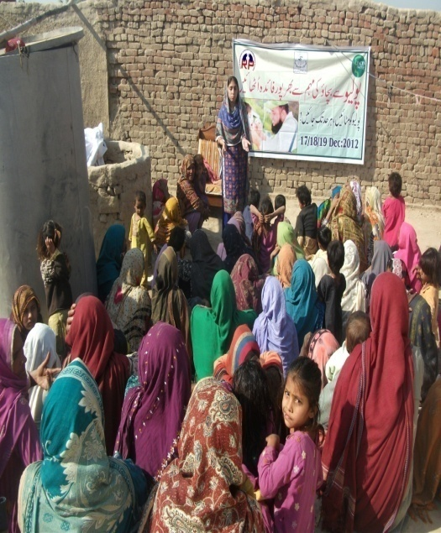
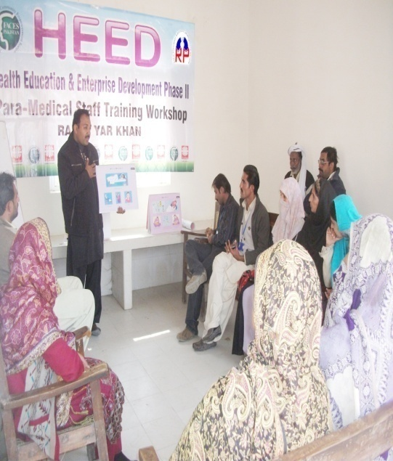
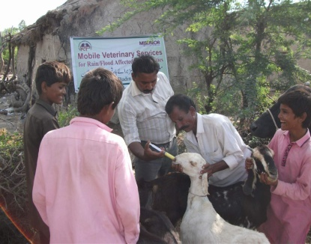

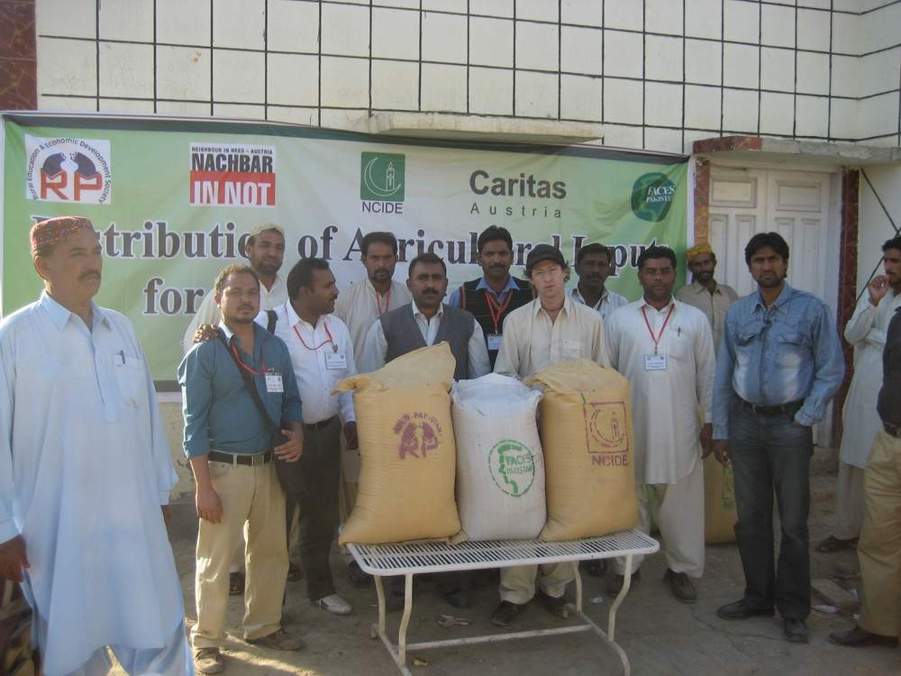

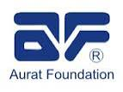

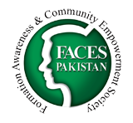

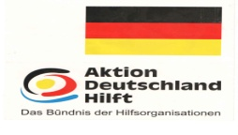
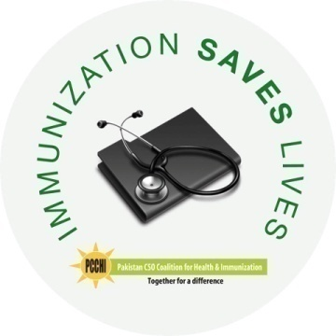

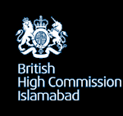
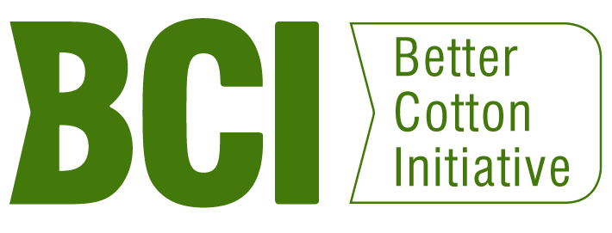
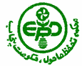
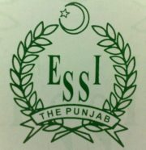
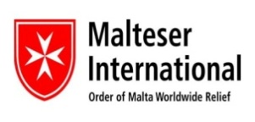
Citizen Commission for Human Development
Caritas
Austria
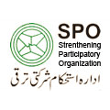

Introduction of REED-Pk: ‘’Solidarity Building towards Sustainable Rural Development’’
Rural Education and Economic Development Society (REED Society) is a non-profitable, non-government and humanitarian organization, registered under the Registration Act of 1860 with the government of Pakistan. REED Society is working for the integral development of the rural marginalized communities without any discrimination of race, creed, and religion in district Rahim Yar Khan since 2002 and become registered in May 2004.

REED-Society appear as a result of in-depth reflection and after having significant review by its likeminded group of men and women concerned for the integral development of the rural society, in response to unsatisfactory development and efforts made for socio-economic development of the marginalized and weaker section of the society
We believe in a golden rule
‘’Go to the people, live with them
Love them, learn from them
Work with them, with what they have
Build on what they know
And in the end
When work is done
The people will rejoice
We have done it ourselves’’
Vision: Integrated human development through change in attitude with promotion of honesty and harmony
Mission: Motivate people for self-confidence for their integral development so that they can move towards a prosperous, free, equal and civilized life.

Community Mobilization process

Goal: Strengthen process that promotes education and economic development of poor rural communities and create an environment for collective change.

Objectives:

- Food security and the improvement of living standard of the rural community.
- Provision of education among school drop-outs/youth through functional literacy and skill development programs
- To promote and protect human rights, especially rights of minorities, women and children.
- Promotion of peace and inter-faith harmony at grassroots level involving youth, religious leaders, women and religious minorities
- To provide preventive, reproductive and curative health care services to the people, especially women and children of marginalized communities.
- To make proficient, transparent, convincing and responsible governing structures and processes where women are enthusiastically participating in local decision and policy-making
- Strengthening of society and the effective participation and integration with other organization and institutions that intervene and determine the processes of sustainable development.

Essential Glance of REED-Pk Programs:
- Social Mobilization and Development
- Food Security & Livelihood Program
- Women Education & Child Development Program
- Preventive Health Education Program
- Humanitarian Assistance & Disaster Risk Reduction Program
- Human and Institutional Development Program

Organizational Methodology

Step-1 Introduction to and immersion in the community
Step-2 Baseline Survey/Social Analysis
Step-3 Nascent group formation
Step-4 Group formation
Step-5 Identification of problems, issues and needs
Step-6 Planning to overcome the problems
Step-7 Action
Step-8 Monitoring, Evaluation & Decisive suggestion
Step-9 Future planning & Implementation

Strategies:
- Awareness raising & Social Mobilization
- Group Formation, Advocacy & capacity building
- Research, debates and consultations
- Information generation, collection & dissemination

International Trainings Staff Participated:

Community Development and Social Mobilization for the promotion of Composite Heritage, Source of Peace and Harmony, organized by Christian Study Center Rawalpindi-Pakistan with the collaboration of EED-Germany for one week in Nepal.

Stepping Stones TOT for community development organized by Action-aid International with the collaboration of CYDA-Punea in Mumbai-India for two weeks.

Governance of Post Disaster Recovery and Rehabilitation organized by FACES and NCIDE-Catholic Bishop’s Conference with the collaboration Caritas Germany in Lahore-Pakistan Mr. Carl Amman was the Facilitator CARITAS-Germany E-mail: k.ammann@web.de
Community Based Disaster Risk Management (CBDRM) organized by FOCUS Humanitarian Assistance Pakistan as part of the project ‘’Harnessing Capacities in Disaster Risk Reduction in the Hazardous Areas of Pakistan’’ held in Islamabad-Pakistan

Organizational Structure

Governance Structure:

- The governance structure of REED-Pk is very strong. It consists of 6 members.
- The meeting of the governing body occurred quarterly, in emergency they can meet any time.
- Mostly decisions take place with the collaboration/understanding of management.
- Executive Director presents quarterly financial and narrative activity report in each quarterly meeting.
- The recommendations given by the governing body implemented which is evaluated on the next quarterly meeting strictly.
- Governing body monitor all the implemented projects.
- Executive Director inform the governing body about all the implemented and under implementation projects, and where they have applied.
- Governing body review all the project quarterly or six-monthly reports before submitted to the partners.

Target Group/Audience:
- Male and female farmers
- Religious leaders of the religious minorities
- Women
- Youth
- Children
- School teachers
- Educational institutions
- Local CSOs/NGOs

Networking and Membership:
- Active member & District Focal Organization for Pakistan CSOs Coalition for Health and Immunization (PCCHI)
- Active member & District Focal Organization for National Humanitarian Network (NHN) in addition member of Provisional Executive Council-NHN
- Member of Scaling Up Nutrition (SUN) Network
- Active member of SPNF and focal organization for Rahim Yar Khan Tehsil
- Active member of CRS Gender Network
- Active member of Eco-Ethics International Union Germany
- Co-Chair for Protection Working Group for Distt. RYK
- Co-Chair for WASH Working Group for Distt. RYK
- Leading Organization for RYK Peace Network-CSC-Rawalpindi
- Peace and Collaborative Network-International

Geographical Coverage:

Punjab:
- Rahim Yar Khan
- Rajanpur
- Bahawalpur
- Multan
- Vehari
Sindh:
- Kashmore

Research Studies and Publication:
- Status of Safe Drinking Water in district Rahim Yar Khan funded by Action-aid Pakistan
- Impact studies of ‘ Fuel Efficient Stoves ‘’ funded by WWF-Pakistan
- Research on Promotion of Safe Drinking Water focusing Arsenic in water in Rahim Yar Khan with the collaboration of HRDS funded by UNICEF.
- Rapid Protection Assessment regarding protection issues in District Rahim Yar Khan with the collaboration of CCHD-Lahore funded by UNHCR-Islamabad.
- Peace situation in District Rahim Yar Khan funded by Christian Study Center-Rawalpindi.
- Status of drinking water as per filtration plants installed by Punjab Government in South Punjab with the collaboration of AWAZ-CD funded by UNICEF.

Publication:
- Essay written on ‘’Mushroom Culture’’ was published in the newspaper by Catholic Times Multan.
- A booklet published on ‘’Kitchen Gardening’’ supported by WWF-P
- A booklet published on ‘’Wheat Production Technologies for flood affected areas’’ funded by FACES-Pakistan And CARITAS-Austria.
- Article written on ‘’Pains of Hunger’’ published in Caritas Calling Lahore.

Average Annual budget managed by organization (over the past 3 years):

Year | Total Budget | Name of the Major Contributor(s)
2011-12 | 27037216 | Malteser-International, Miserior-Germany, Caritas-Austria/FACES-Pk,
2012-13 | 18759004 | Malteser-International, FACES-Pk/Caritas-Germany, WWF-Pk, NBS-Islamabad
2013-14 | 9826075 | Christian Study Center-Rawalpindi, WWF-Pakistan, Alif Ailan, Aurat Foundation, FACES-Pk/Caritas-Germany, AWARE-Faisalabad,
2014-15 | 14051500 | Alif Ailan, Aurat Foundation, FACES-PK, AWARE, BCI and IDH-Netherland

List of projects implemented

Sr.# | Title of the project | Funded by | Implementing year | Total Funding | Employee | Present status
 | Socio-Economic Development of Poor marginalized communities through better livestock management | British High Commission-Islamabad | 2005-2006 | 2175870 | 07 | Completed
 | Awareness sessions regarding HIV Aids | Action aid-Pakistan | 2005 | 210000 | 4 | Completed
 | Promotion of safe drinking water in flood affected areas (Water Quality Testing and chlorination) 2005 | Action aid-Pakistan | 2005 | 98000 | 2 | Completed
 | Distribution of food material in flood affected areas | Action-aid-Pakistan | 2005 | 455000 | 2 | Completed
 | Raising awareness regarding safe and green Pakistan among the Non-Formal Basic Education Centers | Environment Protection Agency-Punjab Government of Pakistan | 2008 | 200000 | 2 | Completed
 | Promotion of peace and Inter-Faith Harmony at Grass root level | Christian Study Center-Rawalpindi | 2008-1011 | 260000 | 1 | Completed
 | Analysis of Water Purification Plants installed in Southern Punjab by the Government of Pakistan and Local Government | AWAZ-CD Foundation/UNICEF | 2009 | 95600 | 2 | Completed
 | Socio-Economic Development of Rural Women through capacity building regarding proper livestock management | AIM-Faisalabad | 2009 | 60000 | 3 | Completed
 | Socio-economic development of poor rural women through better management practices at household level | WWF-Pakistan | 2008-09 | 648000 | 2 | Completed
 | Mobile Medical and Veterinary Services for Flood Affectees of District Rahim Yar Khan | Caritas Germany/FACES-Pak | 2010-11 | 2080000 | 5 | Completed
 | Monitoring of Non-Formal Basic Education Community Schools | District Literacy Department-RYK | 2010 | 178000 | 42 | Completed
 | Integrated Relief for flood Affectees of Tehsil Sadiqabad District Rahim Yar Khan (WASH-Project) | Malteser –International | 2011 | 23988176 | 24 | Completed
 | Agriculture Development program for mixed religious communities Distt. Kashmore Sindh and Rahim Yar Khan-Punjab | FACES-Pakistan NCIDE /Caritas Austria | 2010-11 | 18900000 | 13 | Completed
 | Rapid Protection Assessment in Flood Areas of Distt. RYK | CCHD/UNHCR | 2011 | 100000 | 2 | Completed
 | Relief for rain affectees of District Badin (Agriculture and Health focused) | MISERIOR | 2011 | 3480750 | 7 | Completed
 | Composite Heritage; Source of Peace and harmony | Christian Study Center-Rawalpindi | 2012-14 | 430000 | 2 | Continue
 | Better Cotton Initiatives to preserve nature (Sustainable Agriculture Program) | WWF-Pakistan | 2012-13 | 3144560 | 21 | Completed
 | Installation of Sewerage drains for establishment of WETLANDS | NBS-Islamabad | 2012-13 | 3233200 | 3 | Completed
 | Health Education and Entrepreneur-ship Development Project for mixed religious communities | FACES/Caritas Germany | 2011-13 | 3375455 | 8 | Continue
 | Socio-Economic Development of Farmers through Better Cotton Initiative (Sustainable Agriculture Program) | WWF-Pakistan | 2014-15 | 3638756 | 24 | Continue
 | Community Mobilization ‘’Every Child in School’’ | Aalif Elan | 2014 | 348750 | 2 | Continue
 | Voice and Accountability Project | Aurat Foundation | 2013-1016 | 378560 up-to May 2015 | 2 | Continue
 | Socio-Economic Development of Farmers through Better Cotton Initiative (BCFTF) (Sustainable Agriculture & Environment Program) | IDH-Ireland/BCI | 2015-16 | 13051500 | 24 | Continue
 | Food Security and Livelihood Project for Improving Socio-Economic Conditions of Marginalized Communities in District Rahim Yar Khan | ICCO-Cooperation Netherlands | 2015-16 | 5245000 | 11 | Continue

Organizations funded activities.

Sr.# | Title of the Activity | Category | Funded by
1 | Role of women in family development | Awareness Seminars | JPC-Multan
2 | Democratic Education | Awareness Seminar, Corner meetings | NCJP-Lahore
3 | Promotion of peace and inter-religious harmony among the grass root communities | Awareness Seminars | ASR-Lahore
4 | Livestock development program by providing veterinary facilities | organize veterinary camps in Cholistani villages | Govt. Livestock Department

Capacity of NGO
Assets of the NGO:
S. # | Item | Quantity | Present Value in Rs.
1 | Potohar Jeep (vehicle) | 1 | 6,50,000
5 | Multimedia | 1 | 70,000
6 | Furniture |  | 20,000/-
7 | Computer & printer | 10 | 155,000/-
8 | Ceiling Fan, Air cooler, etc. | 6 | 20000/-
9 | Motorcycle | 2 | 84000/-
10 | Saving of the organization |  | 453000/-
Total Rs. |  |  | 1452000/-

REED-PK Staff & Volunteers

Sr.# | Designation | Qualification | No. of Posts | Male | Female
1 | Executive Director | M.Sc (Hons) Agri. | 1 | 1 | 0
2 | Program Manger | M.Sc (Hons )Agri./MA/DVM | 4 | 3 | 1
3 | Quality Assurance Manger/Officers | M.Sc (Hons )Agri./MA | 4 | 3 | 1
5 | FF/DWFF/SO | Diploma in agriculture/MA/BA/Accredited Training | 32 | 24 | 8
6 | Accounts Manger/Assistant | M.Com/B.Com | 2 | 2 | 0
Total |  |  | 43 | 33 | 10
Volunteers |  |  |  | 425 | 338

REED-Pk information about the activities are also present on Malteser-International website: http://www.malteser-international.org/home/jetzt-helfen/aktionsseiten/malteser-international-in-pakistan.html

